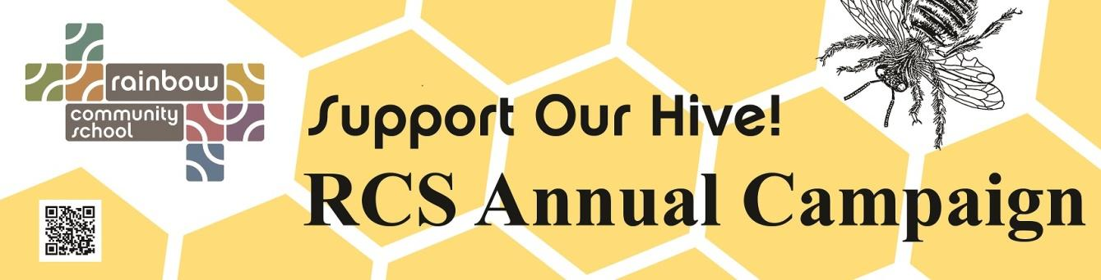
2017-2018

Family Name(s): _______________________________________________ Today’s Date: ________________________
Child/ren at Rainbow: _______________________________________________________________________________
Address: __________________________________________________________________________________________

Phone: ________________________________________Email: ______________________________________________

I / We pledge $ ______________________ to the 2017-18 Rainbow Community School Annual Campaign.

Date I expect to complete payment of pledge: ____________________________________________________________

Signature: _________________________________________________________________________________________

Financial Pledge Options

A check for the total annual pledge amount is enclosed.

I will pay my pledge electronically via Square at the main office.

Please charge the following credit card number: __________________________________________

Exp. Date: _________________________________________________________________________
Name on Card: _____________________________________________________________________
Signature: _________________________________________________________________________

Please bill me through my student account for the full amount on __ (date). __

Please bill me through my student account in ____monthly payments, starting on __________(date).

I/we wish to donate non-monetary items, such as securities, or would like to learn more about planned giving options. Please contact me.

Recognition Options

Please list our name for public recognition as follows: _____________________________________________________
Return to:
Rainbow Community School:
574 Haywood Road, Asheville NC 28806
Or via email to
west.willmore@rainbowlearning.org
Tel: 828.254.9264
With all our hearts, THANK YOU! ♥

We wish to remain anonymous.

Please make checks payable to Rainbow Community School. Rainbow is a 501(c)(3) nonprofit organization and your gift is tax deductible as permitted by law.

