**Event Details**

When: October 12, 2016 8:30-5:00 full day, 1:00-5:00 half day (break out sessions and workshops)

Where: Rainbow Community School, 574 Haywood Rd. Asheville, North Carolina 28806

Cost: $35 for the full day and $25 for the half day.. Breakfast and snacks will also be included and a food truck lunch will be available for ***purchase***.

**Intended Audience:** parents, teachers, school administrators, and other education related professionals.

For more information contact West Willmore at [west.willmore@rainbowlearning.org](http://west.willmore@rainbowlearning.org/)

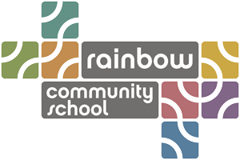

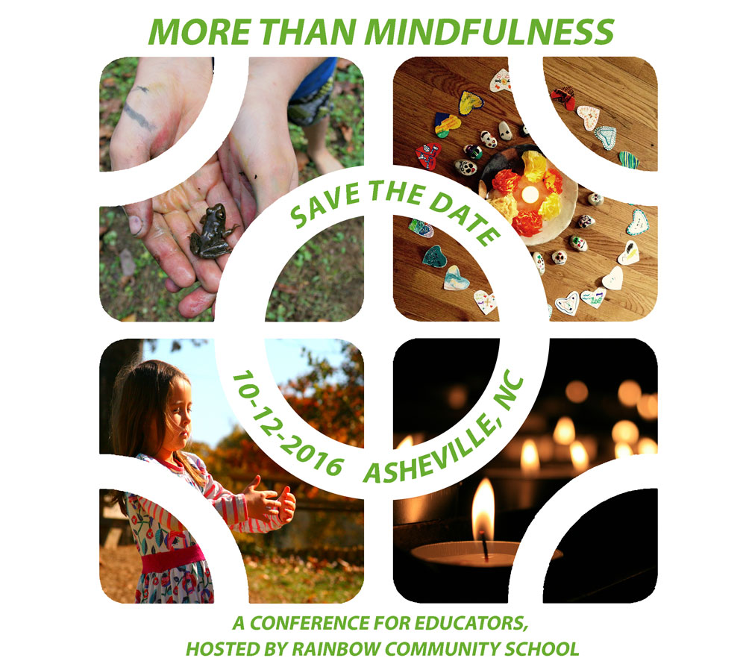

* School based mindfulness programs are becoming increasingly more widespread.
* Research suggests that integrating mindful practices bolsters mental health and improves academic achievement.

* The More Than Mindfulness Conference will highlight ways to integrate mindful practices, contemplative and centering practices, exploration of world religions, cultural traditions, as well as sacred rituals, myths and stories and into your schools.

Participants will experience RCS’s unique centering curriculum, gain holistic strategies that can be adapted for all school curriculums and cultures, and collaborate through discussion and interactive sessions on these important themes: ***inviting the soul into the classroom, cultivating awareness and spiritual identities, and exploring education as a sacred art.***