Rainbow Community School
Annual Report
2015-16 School Year

Enrollment
Budget target (K-8): 164
At the start of the school year: 164
At the end of the school year: 168

 | Target for K-8 | Start of School Yr. | End of School Yr.
2012-2013 | 98 | 96 | 106
2013-2014 | 125 | 119 | 126
2014-2015 | 144 | 149 | 151
2015-2016 | 164 | 164 | 168

Except for one undersized class (5th grade with 12 students), all K-8 classes were at capacity, and several had an informal wait list.

Preschool Budget target: 42, for a full time equivalent (FTE) of 36.
At the start of the school year: 42 (36 5-day, and 6 2 and 3 day students), with 36 FTE
At the end of the school year: 36 FTE

In 2015-16 there were 36 students (30 families) on financial aid, and $103,564 awarded.

Faculty and Staff

Faculty
Executive Director: Renee Owen
Preschool: Jessica Redford, director. Leads: Katie Waldowski, Lucy Mc Gregor. Assistants: Bryan Gillette, Liza Kelly. Preschool after school lead: Brittany Beecher; Asher Zaccagnini, preschool after school asst.
Kindergarten: Jessica Redford, lead. Doreen Dvorscak, asst.
First: Rachel Hagen, lead; Clarissa Harris, asst.
Second: Eddy Webb, lead; Abby Camaya, asst.
Third: Chris Weaver, lead; Pamela Goodrum, asst.
Fourth: Susie Robidioux, lead; Walker Trent, asst.
Fifth: Melissa Scott, lead; Jill Cox, part-time asst. and as more students enrolled, Josie Hoban was added to assist in fifth grade on Wednesdays.
Sixth: Jenny Armocida, lead; Justin Pilla, asst.
Omega (7th-8th): Leads: Susan Swanson, Niki Gilbert and Jason Cannoncro; Kyja Wilburn, asst.

Omega Electives Teachers: Sandra McCassim, Home Ec; Facilities Internship, Max Mraz; 2-D Drawing & Painting, Dimensional Sculpture, Graphic Design, Tracy Hildebrand; Computer Coding, Nicholas Rake; Creative Writing, Susan; Typing, Ali Banchiere; Dance, Lindsey Kelley; Theatre of the Oppressed, Ange Moore; Choral Explorations, Band, Marimba Percussion Ensemble, Sue Ford; Personal Mythology, Basil Savitsky; Primitive Skills, Walker Trent; Social Change, Kaya Wilburn; Theatre, Katie Turner.
Student Support Coordinator, Ali Banchiere; student support advocates, Jill Cox & Viviana Saraceno.
Spanish: Lisa Saraceno, 4-8, Ange Moore, p-3.
Music: Sue Ford
Art: Tracy Hildebrand
PE: Mark Strazzer

After School
Denisa Rullmoss, director
Makasi Siriwayo
Tybie Maitri
Ange Moore 1st trimester, Nicole Halperin 2nd & 3rd trimesters

Other:
Creative Coordinator: Justin Pilla
Director of Equity: Kyja Wilburn

Staff
Admissions: Sheila Mraz
Director of Operations: Sandra McCassim
Office Manager: Kate Chassner (Kristin Candell for maternity leave)
Media Specialist & Office Assistants: Jessy Tickle (Ange Moore for Maternity leave)
Tech Specialist: Michael Valentino
Business Manager: Margaret Gerleve
Custodian: Peter “Wind” Motika
Maintenance: Max Mraz with part time help from Mike Ducar “Dr. Mike” and Shaun Fain

Professional Development for 2015-2016 school year

RCS encourages the personal and professional growth of its teachers through a thorough and holistic professional development program. For example, our lead faculty is contracted for 178 days of which 14 are full day teambuilding, professional development or work days. This is roughly 12% if the academic calendar which exceeds the North Carolina Department of Public Instruction (2013) average of 9 out of 194 designated work days which translates to 4.65% of the academic calendar. Additionally, RCS has early release Wednesdays which are designated as additional faculty fellowship and meeting times, curriculum work days, child study and professional development days.
The calendar was structured so to provide a 7 full days of trainings, meetings, orientation and the retreat prior to school starting. The calendar also allowed for early release every Wednesday for faculty meetings and trainings. Finally, below is a comprehensive list of the professional development experiences that our faculty and staff attended or enrolled in on their own.

Spiritual Domain:
- Mehera Kleiner, former RCS parent, facilitated a training on the The Work of Byron Katie which is an exploration in self Inquiry and compassionate conflict resolution.
- Lucy McGregor facilitated Mindful School "moments" from the Mindful Schools curriculum. These “moments” were spread out over the course of the year.
- Katie Waldoski attended a Mindfulness Fundamentals course

Social Domain/ Emotional:
- Ashley Cooper of Mycelium coordinated and helped facilitate a cultural Responsiveness, equity literacy and cultural competency training.
- We had approximately 10 staff and/or community members participating in Building Bridges this year.
- Kyja Wilburn. Director of Equity facilitated an book study group using the book Everyday Antiracism.
- Chris Weaver introduced Open Space Technology- The Art of Facilitation as a platform for staff support and collaboration.
- West and Susan facilitated a follow up on the Positive Discipline approach to behavior management and conflict resolution in an effort to bring more consistency across the grade levels.
- Green River Preserve staff facilitated a 2 hour teambuilding course during our staff retreat.
- Rainbow parent Chris Burris facilitated 2, 3 hour trauma training for the preschool teachers.

Natural Domain:
- Sandra McCassim and West Willmore facilitated the launching of Citizen Science programs across all grades.
- NC Arboretum met with K-3 grad teachers and students 4 times per year.
- Green River Preserve staff facilitated 2, 3-hour nature awareness hikes.
- Three faculty members are enrolled in the Inner Life of a Child in Nature Program through the Center for Education, Imagination and the Natural World.
- One faculty member enrolled in the NC Environmental Education Certificate program

Mental Domain:
- A SMART Board trainer from Buncombe County facilitated a SMART Board training for the 6-8 grade teachers
- A SDE trainer, facilitated a full day, Singapore Math Training for the k-6 grade teachers
- Institute of Play offered a follow up on games based learning and emphasized design and engineering for the 4-8 grade teachers
- Candi Sellers of The Key School offered an introduction to an Orton Gillingham inspired cursive curriculum for the k-3 grade teachers
- Asheville Speech Associates facilitated a language based learning difficulty training for the preschool teachers
- Three RCS faculty and staff members are enrolled in graduate or doctorate program in course related projects are RCS applicable. One faculty member is enrolled in a M.Ed. program through Gardner-Webb. One staff member is enrolled in a NC School Leadership/ Administration Licensee program through Appalachian State University. One faculty member is enrolled in a Ed.D program through Columbia University
- Two faulty members finalized her Orton Gilliagham Reading certification
- Susan Waddell completed her M.A. in curriculum instruction
- Jessica Redford attended a Reggio Inspired Practices in the American Classroom

Physical Domain
- All faculty members are CPR & First Aid certified
- Jessica Redford attended an emergency Preparedness and Response

Creative Domain
- Tracy Hildebrand attended a screen printing class and cloth fiber workshop.

Across all Domain
Our staff collaborated on designing and implementing RCS’s inaugural Domain Day.

Additionally, some training days were designated as PLCs and/ or Child Study. Both were structured times that are meant to help meet the growing demands of teacher’s time through a collaborative approach to student, curriculum, and assessment reflections and feedback that may guide instruction so to improve students experience and performance.

Notable Conferences and presentations:

- West represented RCS as and Ashoka Change leader at the Changing the Odds Conference at the Momentous Institute in Dallas, TX.
- West presented at the SxSWEdu conference in Austin, TX.
- West presented at the Virginia Tech Higher Education Conference.
- Jenny presented at the Freedom Foundations Organization Conference
- Renee and Kyja represented RCS as a Ashoka Changemaker School at the Ashoka Summit
- Renee represented RCS at the Ashoka Changemker book sprint.
- Lucy presented at the Week of the Young Child Conference and Buncombe Partnership for Children- her workshops were titled Mindfulness for Early Childhood Educators and their Students.
- Susie’s published “What Really Matters: Exploring Love in the Classroom” in NAIS

Fundraising
The annual campaign goal was $80,000, and was surpassed, with $92,000 begin donated for the annual campaign.

Third year capital campaign donations helped to fill in the reserve.

$21,000 was raised to purchase an activity bus, and one bus for $9,000 was purchased before the end of the 15-16 fiscal year, and a second was purchase for $11,000 later in the summer.

Milestones and Mention-ables:

Rainbow Community School became “complete” this year. We finished renovation construction on the community building within budget and in time to open it to 40 7/8 graders. For the first time, we had a full size room for each class, P-8. Preschool is two classes combined into two multi-age rooms, and 7/8 is two classes combined into two multi-age rooms. This was a huge accomplishment and milestone (largest enrollment ever), but it had been planned for and was implemented quite smoothly. 7/8 grade was almost twice as big as the previous year, and while students and parents had to adjust to the different culture, one of the biggest advantages was the new slate of electives Omegans had to choose from on a trimester basis.

West and Renee put together an all-star team to design a high school. Our concept for “rEVOLution High” was submitted and accepted by XQ. We made it to the semi-finals of the compention.

This year’s holiday program was all original music on the theme of Love.

The 7th/8th grade Omega class had their first TED-inspired talks and also had their first Design Fair which included a planning day field trip for students to be immersed in their project in the field.

The 6th grade class started businesses again through their Entrepreneurial Projects. They sold their projects at the Farmer’s Market and the French Broad River Festival. All of the students donated a % of their proceeds to different non-profits or causes.

The auditorium stage floor was changed from carpet to refinished hardwood and a stage curtain was added. The auditorium and other classroom spaces were rented out on a regular basis, bring in some extra money and creating community connections. The Gathering Church rented it out every weekend for the second half of the year.

One of our goals for the year was to become a more diverse community – a complex and sensitive goal that requires a major shift in culture and understanding. However, we made some positive strides in that direction by hiring the most racially diverse staff ever, and opening up enrollment to affirmative actions scholarships.

Justin, West, Jason and Renee completed the Domain Document which is an informational document that explain our Seven Domains approach to learning.

Multiple Awards and Honors

Individual Teachers:
Last year, Jenny Armocida, our grade 6 teacher was awarded the Leavey Award from the Freedom Foundation in Washington, D.C. The foundation awards twelve educators from around the country (elementary through college) for innovative entrepreneurship programs. This year she received $15,000 and presented the entrepreneurship curriculum on a panel for the national social studies conference in New Orleans November.

Mark Strazzer, our P.E. teacher, was part of a team that won Nationals for Ultimate Frisbee he will be playing on Team US two years in a row.

West Willmore presented with Ashoka at the South by Southwest conference in Austin, TX.

Susie Robidoux , 4th grade teacher, wrote a piece about teaching love that was published on the NAIS website.

Renee Owen co-authored a book with Ashoka and nine other educators called “Changemakers: Educating with Purpose,” which is now available on Amazon. She also published a guest editorial on the Citizen-Times on culture and racial equity in schools – a response to Niya Kennedy’s arrest in Spring Valley, SC.

Began work toward the Rainbow 40th anniversary event, by starting an alumni facebook page.

Local:

Odyssey of the Mind advanced to the state level.

WNC-Best of:
Best Science and Tech program 1st
Best School ^{2st}
Best Preschool 2st
Best Music Teacher (Sue Ford) 1st
Best Art Program 2nd

School-wide State and National Awards
North Carolina Green School of Excellence
Ashoka Changemaker School (continual)

Data Report

Staff Culture and Climate
RCS teacher retention is also an indicator of a strong culture and climate. The RCS faculty and staff retention rate for 2014-2015 was 9%, all of which were voluntary turnovers. This turnover rate is lower than the state average of 14.84% (Department of Public Instruction, 2014). Furthermore, the results of the 2015-2016 staff intention survey reflect that 90% of the respondents are intending to return and the remaining 10% marked “maybe.”
School Climate Index (Tschannen- Moran, 1998) measured against schools nationwide:
Subscale | Percent higher than other schools
Teacher Professionalism | 97%
Collegial Leadership | 84%
Community Engagement | 84%
Academic Press | 84%

Student Culture and Climate

The Student Trust in Faculty Scale (STF) (Adams & Forsyth, 2009) measures the level of trust students have for their teachers. This measure to “capture student perceptions and recollections of teacher behavior, which allow for judgments to be made about their relative openness, benevolence, reliability, competence, and honesty” (p. 264). The STF for RCS is higher than 84% of the schools with a score of 639.14.
The Interpersonal Reactivity Index (IRI) is a measure of dispositional empathy and the instrument contains four seven-item subscales, each exploring a separate feature of empathy (Davis, 1983). Twenty-five 7th and 8th grade students completed the IRI. Omega Middle School students more often (59%) selected “A lot” or “Always like” me when answering questions. This may suggest that our students have a strong ability to empathize with others.

Parent and Community Culture Data
The survey results for the RCS parent survey (2015) were overwhelmingly positive and show support for a positive culture and climate. For example, 96% of parents agreed that the school climate is “positive and child centered, and the school's mission and beliefs are generally achieved” and 90% would recommend RCS to another family.
Information and services provided by the office | 94% satisfied
Child Safety | 90% satisfied
Overall academic program | 95% satisfied
School grounds and facilities | 93% satisfied
School philosophy | 98% satisfied
Quality of teachers | 95% satisfied
General leadership | 99% satisfied

Parents were also asked to consider seven aspects of the organization and rate their overall satisfaction. Each survey element achieved an 90% or higher very good or good rating by the respondents.

Proficiency data

RCS embraces a balanced approach to assessment. Ongoing, authentic and formative assessments are embedded within the classrooms weekly. Additionally, extensive narratives are written for each child during each trimester. RCS also administers a standardized test for each RCS student third through eighth grade. The SAT10 test typical trends over the years show scores generally being slightly above average in Language Arts, Math and Reading in the lower grades and extremely high in the upper grades.

Lectica Test Results

Rainbow Community School Lectica scores shows higher student development than any school tested. (Note that Lectica has graphed out the projected developmental levels of students older than 8th grade)

Rainbow’s 4th-8th graders took the Reflective Judgment test, which reveals how they think about inquiry, evidence, learning & the mind, truth & certainty, conflict resolution, persuasion, and deliberation. The test consists of open-ended questions about dilemmas, such as ethical dilemmas or societal issues. Students wrote essays in response, and defended their thinking. Lectica has a complex scoring system that codes each response and examines lines of reasoning in order to determine cognitive development.

Lectica Test Results

RCS student’s level of coherence was higher than they had ever seen. Coherence is the ability to connect thoughts intelligently and develop a persuasive argument.

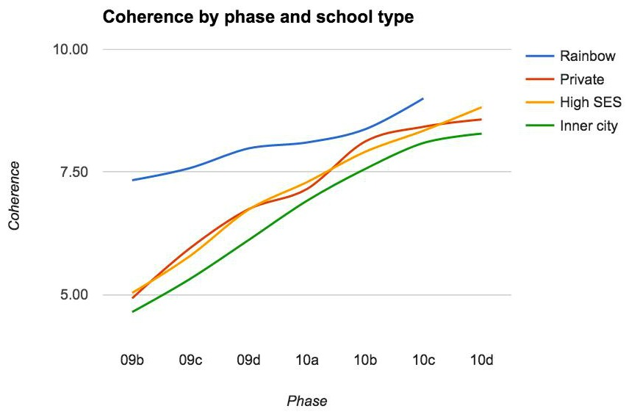

SAT 10 Results

This is the last year for Rainbow to use the SAT10, as it is being discontinued. We are switching to the CPT next year, so our data will be very different, and not comparable to previous years.

2015-16 Test Results: Rainbow’s SAT10 test typical trends over the years show scores generally being slightly above average in Reading, Writing, and Math in the lower grades and extremely high in the upper grades (with usually a couple of classes being outliers.) Our theory regarding this trend is that we have a different trajectory than traditional schools. We introduce rote Reading, Writing, and Math skills slightly later than traditional schools and prep schools, in favor of giving them more time to work in intellectual rigor in content areas, such as Science and Social Studies. Also, by not pushing rote skills early, we are able to introduce greater challenge later – thus, the high scores in the later grades. In Science and Social studies, scores very a high throughout – extremely so in science, further proof of our theory. It is interesting to note, however, that this year in reading, scores are quite high throughout the grades, but this likely means that 4th grade is an outlier, with exceptionally high scores and large number of academically gifted students.

Other notes: Consistently, our Language Arts skills, while respectable, are not as high as our Reading scores. Last year, West was looking into finding a nationally norm-referenced writing test, which will provide us much more accurate information, as it will actually score students on their essay writing abilities (rather than merely grammar skills, such as the SAT 10.) She never found one that was satisfactory. Then we discovered Lectica, which tests some of the complex, critical thinking that good writing requires – after all, students write their Lectica answers in essay form.

Grade | RCS Avg READING Percentile Ranking
3 | 62.6
4 | 85.7
5 | 81.7
6 | 82.7
7 | 82.7
8 | 89.8

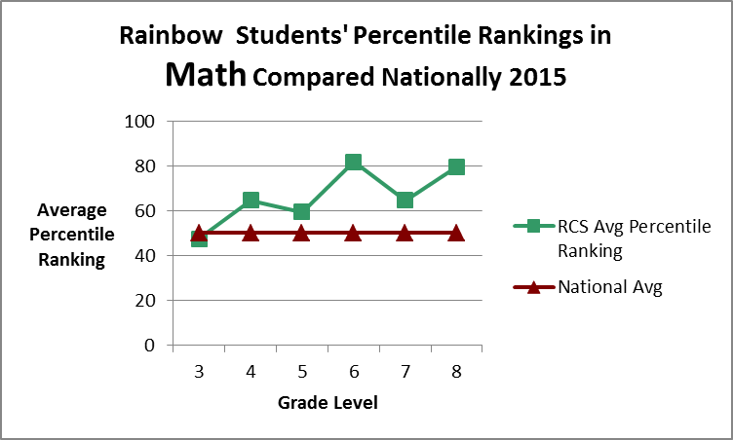

Grade | RCS Avg Math Percentile Ranking
3 | 47.5
4 | 64.6
5 | 59.5
6 | 81.7
7 | 64.6
8 | 79.7

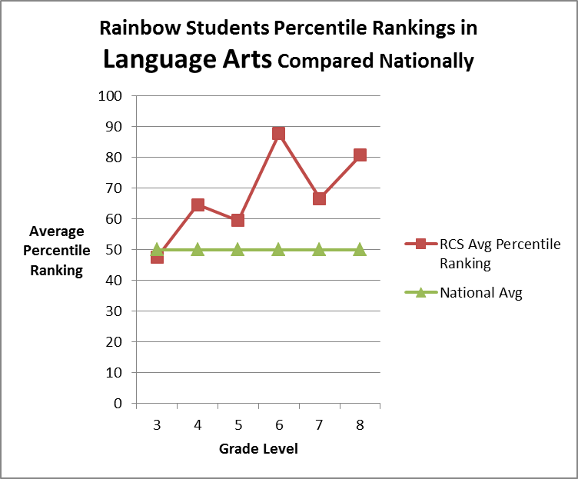

Grade | RCS Avg Language Arts Percentile Ranking
3 | 47.5
4 | 64.6
5 | 59.5
6 | 87.7
7 | 66.6
8 | 80.7

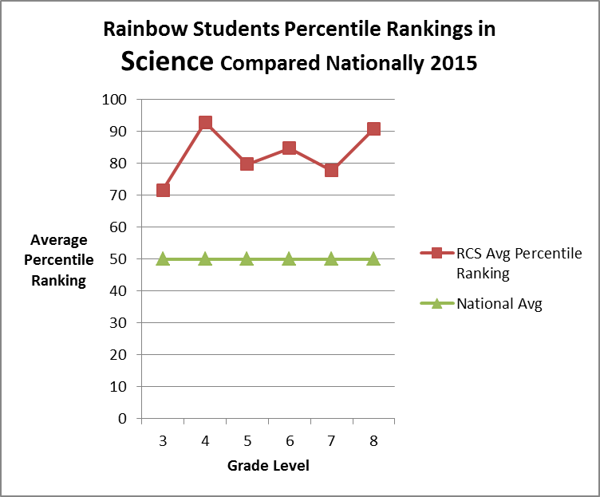

Grade | RCS Avg SCIENCE Percentile Ranking
3 | 71.6
4 | 92.8
5 | 79.7
6 | 84.7
7 | 77.7
8 | 90.8

Eighth Grade Gradation
RCS graduated 18 students, going to a variety of schools:

Achievements in Various Domains

Mental

In partnership with the Asheville Chamber of Commerce and local businesses, the 6th grade investigates the world of commerce by creating, implementing and sharing their researched business model. Students are asked to interview local businesses, engineer a viable business model, create a cost analysis and present their business to the community in a PowerPoint presentation and with business cards and fliers. All business plans will have a socially beneficial factor and students had the opportunity to sell at the West Asheville Farmer’s market.

In lieu of a science fair, Omega hosted a Design and Innovation fair. In the initial stages of the Design Challenge, students were asked to research an innovator whose innovation reflected an ideal from the Enlightenment, uncovered a truth to the greater community, and, most importantly, was an inspiration. At the Design Fair, student papers were presented. In addition, 15 Omegan design teams used the Design Thinking method to innovate for a local, national or international problem.

Omega students research and create mini-documentaries on a passionate topic, we call this personal interested projects (PIPs). This year Omega PIP presentations were inspired by Ted Talks.

With the growth in Omega, the program had some changes.
- The schedule changed to an A/B schedule so that students alternated between a Science focused Main Lesson and a History focused main lesson Mon- Thurs. Fridays offered two shorter main lessons that both the science focus and history focus are included on five day weeks.
- Students were able to choose three elective each trimester.

List of 2015 -16 Omega Electives
Home Economics
Writing Basics
Creative Writing Workshop
Literary Journal
Facilities
Choral Explorations
Marimba Percussion Ensemble
Band & Music Creation
Drama
Theater of the Oppressed
Modern Dance
Vintage Jazz & Swing
Poyodoshi (Personal Mythology)
Social Change
Study Hall
Computer Coding
Primitive Skills
Drawing and Painting Fundamentals

Creative

The Imagine performance this year was a theatrical production featuring individual class performances nestled into the greater structure of the sixth grade play. “The Dream Parade” was a mythic journey through which the audience was transported to a mystifying world where imagination and dreams come to life and slip into our basic reality.

42 students from Rainbow’s End Afterschool Drama club performed the Treasure Island classic by Robert Louis Stevenson. The theme of the play was one of empowerment, imagination, and actualization as the main character, Josie learns that in the end it truly is always her adventure no matter what obstacles and challenges come her way.

The Winter program embraced a them of Love. ALL the songs were written by the students along with Sue Ford and classroom teachers. Plus, Billy Goodrum, RCS parent and internationally acclaimed composer, made a special appearance with two songs Omega students wrote with him. The theme of every song was love.

Sue Ford also facilitated an all school song circle each week.

After each Omega elective trimester, students celebrated their knowledge through an Elective Showcase. Student work was shared via visual representation, performance and/or presentation.

Natural

Grades k-8 participated in citizen science projects throughout the year.

Walker Trent, school naturalist, facilitated nature awareness regularly for grades 1 and 4.

West facilitated nature awareness with k, 4 times over the course of the year.

Grade 3 raised chickens, cared for class pets, build bird houses for campus, participated in an overnight camping trip and rafting trip.

Grade 4 had much success growing food in the school garden.

Omega offered a primitive skills elective.

Both preschool classes and grade 1 cared for class pets.

Spiritual

Grade 6 piloted a 9-week Mindful Schools curriculum.

Omega offered a personal mythology elective.

Social/Emotional:
Service learning, community service and establishing local and global partnerships helps students improve academically, develop social and cultural literacy, and work collaboratively to meet a variety of community needs. By playing a significant role in designing, planning, and implementing their service learning and community service projects, students develop practical skills, self esteem and a sense of community responsibility. Here is a list of the projects and programs our students participated in last year.

- Preschool headed up a mitten, hat and warm coat drive for Children’s First.
- Kindergarten making valentines for Meals on Wheels recipients
- 1st grade grade packed, sorted and organized food at MANNA again this year.
- 2nd grade sang to the seniors at the Senior Opportunity Center
- 3rd grade build and installed bird houses on campus
- 3rd grade presented their Citizen Science project at the Asheville Science Expo
- 4th grade set up a donation table for Brother Wolf and raised over $150.00
- 5th grade established an ongoing relationship with the elders at Bella Vista Gracious Retirement Living. They read, sang and recited poetry. They participated in community building & relationship building activities
- 5th grade participated in a stream clean up with Riverlink
- 5th grade maintained the NWF certified wildlife habitat.
- 5th grade donated fundraising money to Heifer International
- 6th grade launched socially beneficial businesses that had a service component - most donated to causes such as Brother Wolf, Homeward Bound, Manna Food Bank, and Doctors Without Borders.
- 6th grade donated proceeds from handmade greeting cards to Heifer International
- Each Omega student acquired 10 hours of community service.
- Mark S. and West headed up a Strive Not to Drive community station for the City of Asheville, students from various grades volunteered to help.
- The school community promoted and participated in the Local Strive Not to Drive Week and the National Screen Free Week.
- The school-wide Harvest Hoedown Raised a little over $1,250 for Children’s First and gave free Hoe Down tickets for Children’s First to distribute among their families.
- Rainbow’s End Afterschool Furry Fridays Club donation day to Brother Wolf

Other Social mentionables:

The buddy system was continued preschool-8 in which two classrooms paired up and met throughout the year. These meetings included buddy reading collaborative projects.

1st grade and Omega started a new tradition called the Rose Ceremony. This ceremony happens at the beginning and end year. Opening the year by celebrating the start of the year by welcoming the rising 1st graders and then closing the year by recognizing the graduates.

We hosted the inaugural Domain Day. A Domain Day is an opportunity for students to gather together in groups based upon a specific elected Domain and to spend the entirety of the Day engulfed in the experience of that Domain. Domain Days give an opportunity for children to be immersed in an educational experience relating to a Domain to which they are innately attracted. As well, since the ages will be blended, it is an opportunity for students to interact in an educational setting with peers they may not generally mingle with due to the natural age boundaries of each class.

Physical:

Hospitality was well attended and overall a huge success. Volleyball and ultimate Frisbee was added. The Soccer team was undefeated.

Financial Summary for the 2015-16 School Year

Revenues:
Tuition and fees | $2,166,434
Grants | $16,375
Combined Campaign 3rd yr, Annual, Bus | $219,074
Events and student fundraising | $13,673
Rental Income and misc income | $18,336
Total Revenues: | $2,433,892

Expenses:
Staff salaries and wages | $1,400,986
Staff expenses (benefits, training, taxes, etc.) | $323,645
Facilities | $114,919
Utilities, phone, internet | $41,846
Mortgage (principal & interest) | $115,137
Marketing | $32,212
Fundraising | $6,760
Ed. Materials, Equipment, services | $185,260
Property/Liability Insurance, taxes | $33,874
Other | $26,539
Depreciation | $30,439
Total Expenditures | 2,311,617
Difference: Revenue-Expenses | $122,275

Equity
The total value of all assets at the end of the 15-16 fiscal year was estimated at $3,383,005.
We ended the year with a cash/savings reserve of $475,500.

Fundraisers and Major Events
Harvest Hoedown included a raffle and booths provided by Parent Council. The Hoedown raised approximately $5,100 and 25% of that went to Children First/Communities in Schools.

Shine, the student talent show, was held in February.
Hobey Ford donated a puppet show, which generated about $600 in ticket sales.
The bus fundraiser raised $21,000 total, but $4,000 was raised the year prior. The bulk of the raised funds came from fundraisers with Wicked Weed and LaZoom bus.

The annual campaign raised $100,000 -- $20,000 more than the $80,000 goal.

Other Major Community Events
The Holiday/Winter show
Graduation

Marketing
We did a few Google ads near the end of the year for the middle school.
We did a print ad in the Xpress to boost votes for our Best of Awards.
Regular postings on Facebook.
A new marketing committee was formed, headed by West Wilmore

Communications
The Omega class published a full-color Yearbook
Rainbow Reminders was published every Wednesday
Kaleidoscope was published monthly
Heart of the Matter was published twice – “Truth” and “Beauty”
The Community Connector, went out once a week, and was a huge hit! It is a newsletter about Rainbow-family-friendly news and events.

Parent and Board Committees
Finance
Tuition Assistance
Parent Council
Annual Campaign Committee

Governance
Board members at beginning of the year:
Claudi Konijn, President
Stewart Stokes, Vice president
Keith Costello, Officer of Finance
Alyssa Augustine, Secretary
Cheryl Dalton
Jeff Bachar
Zach Adams
Renee Owen
Susie Robidoux, faculty rep

Board members at the end of the year:
Claudi Konijn, President
Stewart Stokes, Vice president
Keith Costello, Officer of Finance
Alyssa Augustine, Secretary
Cheryl Dalton
Jeff Bachar
Renee Owen
Susie Robidoux, faculty rep

