

Presents the
More Than Mindfulness Conference
Education as a Sacred Art
October 6 & 7, 2017

Keynote Address

Establishing a Heart Centered School- Who are children really? Where do they come from? What kind of educational environment provides them with the best chance of loving themselves? Of developing fully? Of expressing all that they are? And of living harmoniously in a way that contributes to others and to our world? These are the questions that we asked ourselves as we were designing Rainbow Mountain Children’s School 41 years ago. The heart is the key: first, because children are centered in their hearts ; secondly, because the heart is the doorway to the brain, as we now know from research; and thirdly, because the heart is the faculty that knows the essence of life on both the seen and unseen level. The language of the heart is connection and love. Education that opens up the experience of love and unity leads students to excel and thrive in all areas of their lives. Children's hearts are alive, vibrant, and curious. The heart is their main channel of learning. As educators and parents, when we tap into their hearts along with their minds, we bring out the best in them and help them to be all that they are created to be. This is education in service of healing and transformation. It is crucial work for our time. It is holy work. Through lecture and experiential exercises, we will explore how we can reach and nurture children’s hearts so that they are fulfilled, productive, and in service to others.

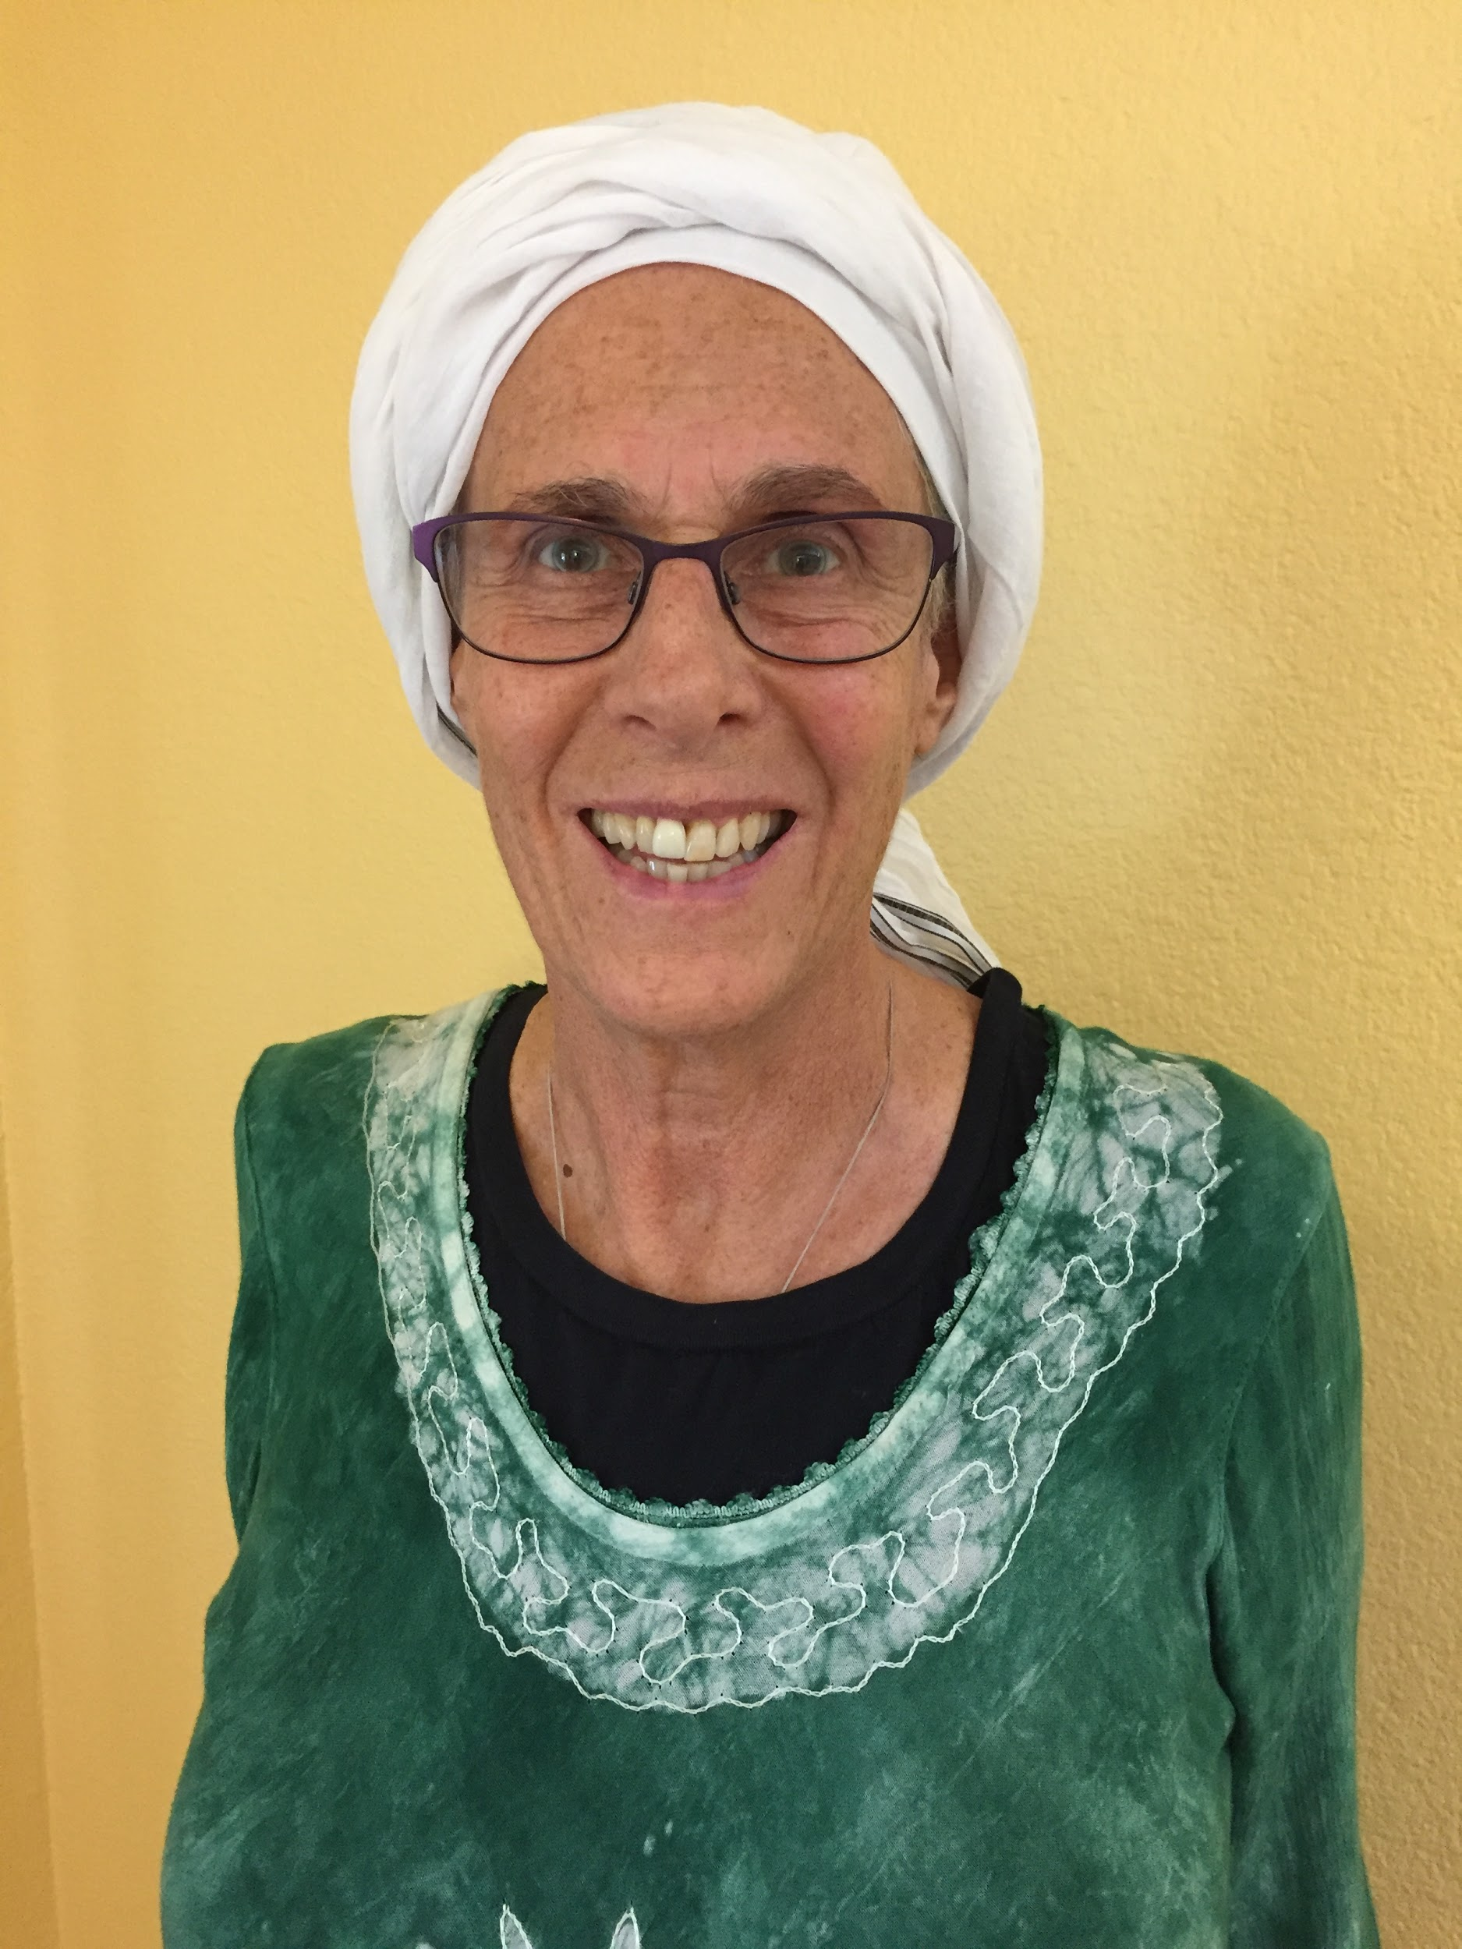
Led by Nura Laird. Nura, formerly known as Ashrita, was one of the original founders of Rainbow Community School in 1977, known then as Rainbow Mountain Children's School. She has been an educator in public and alternative schools since the early 1970's. She co-founded both an alternative secondary school in Vermont before Rainbow and, more recently, the University of Spiritual Healing and Sufism in Northern California. Nura has been a lifelong advocate for children as well as a parent educator and coach. She spearheaded a formal research study in spiritually-based parenting and family healing which later became one of her student’s PhD dissertations. Nura is also a mediator with extensive experience in family mediation and is skilled in a number of counseling modalities. She works mostly with couples and family members to resolve conflict and to restore love and harmony to families. For the past 40 years Nura has been a student of Sufism, the age-old Islamic mystical path of wisdom and love. Currently Nura is a professor of Sufism, spiritual healing, and peacemaking at the University of Spiritual Healing and Sufism in northern California. She teaches internationally and has a private healing practice in St. Helena, California, working both in person and remotely by phone or online.

Spirituality: A catalyst for transformative learning and advanced human development-
In this workshop session Renee Owen and Susie Fahrer will present research on how spirituality enhances learning and wellbeing for children and adults. We will begin by sharing Rainbow’s approach to secular spirituality. We will look at the phases of human development theories, from Piaget to Kegan, and think about why and how spirituality can provide fertile ground for individual cognitive development and societal progression toward higher levels of consciousness. The format for this session will be lecture with discussion.

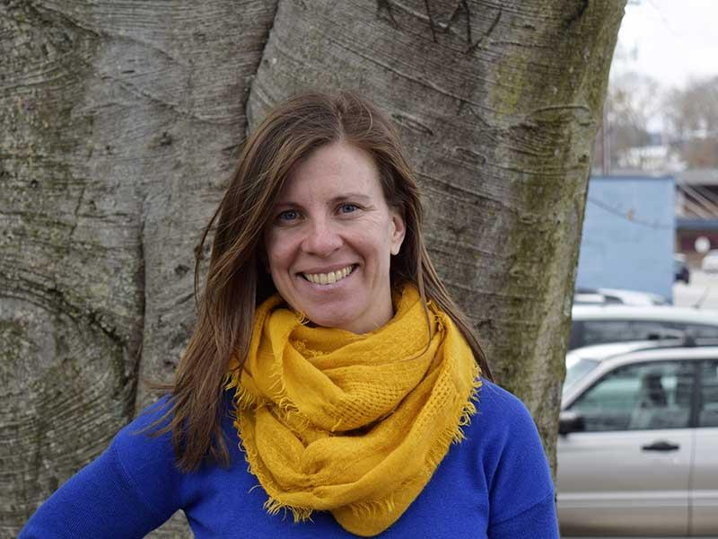
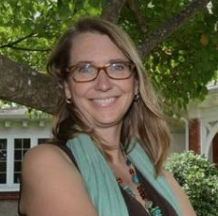
Led by Renee Owen and Susie Fahrer. Renee Owen is passionate about educating children and adults to be mindful humans. As Executive Director of Rainbow Community School since 2007, she has witnessed the miracle of an education that includes mindfulness and secular spiritual practices embedded in children’s daily lives. Renee is also co-founder and CEO of Rainbow Institute, the newly formed adult education organization dedicated to training teachers, therapists, and parents on how to include mindfulness and other secular spiritual practices into their classrooms and lives. She is a doctoral candidate at Columbia University’s Teachers College, and her extensive research is on secular spirituality in education and spiritual development from childhood through adulthood. * Susie is the RCS Dean of Faculty and 4th grade lead teacher. She has degrees in both Elementary and Special Education, which have allowed her to serve in various positions and multiple settings in her professional career. She is highly invested in holistic child-centered education and seeks to engage the Rainbow Seven Domains™ inside and outside of the classroom.
The Sacred in Science- Science is a core subject in the learning journey of a child. But science is also a way of knowing and is therefore sacred. This is a workshop that excerpts from science lessons those things that are already connected, common experiences. Together, through hands-on demonstrations, we will seek to honor the interesting ways you already are a great teacher and an observant student of life. If you get inspired by the beauty of science, even momentarily, you are already celebrating the sacred.

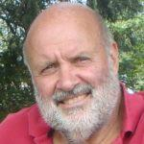
Led by John Bickart. John is a 40 year veteran teacher of both children and adults. He is also an educational consultant. His goal as a teacher is to work in the background while letting good ideas speak for themselves. He believes that teachers and students know what they want and that we empower ourselves when we listen to our hearts. He values helping his students transform personally over simply passing along information. His professional offerings include: higher ed. pre-service teacher preparation, in-service teacher workshops, high/middle school science and math for youth at risk, science topics for incarcerated individuals, and educational software development.

Character Strengths to Optimize Life Fulfillment- This workshop offers a hands-on approach to identifying one’s passions and character strengths in order to create a life that aligns with who you really are. We will interactively explore the practical uses of positive psychology and other resources that engage us to optimize life fulfillment.

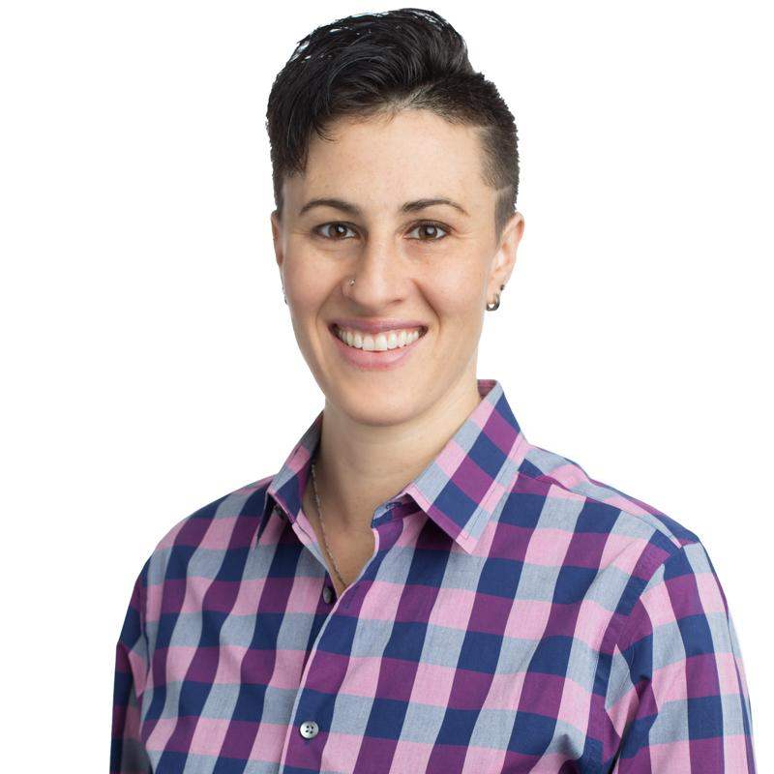
Led by R. Kamela Laird. Kamela founded Integrate Legacy Law with the commitment to guide her clients to identify their life purpose and to integrate that legacy into their lives in a way that makes a lasting difference. As an experienced communication and relationship coach, mediator, and spiritual counselor, Kamela integrates these skills with her legal training to provide a holistic approach to estate planning. She has a special knack for supporting clients through conversations with family members regarding end-of-life, incapacity, and guardianship. Kamela was raised in Asheville, North Carolina and is an RCS alumna. She moved to California to attend Santa Clara University where she graduated as Valedictorian. Kamela loves sailing, scuba diving, salsa dancing, camping, and traveling to as many foreign destinations as possible. Kamela practices mindfulness and wholeheartedly believes in work-life balance.
Mindfulness as Playfulness: Experience first-hand the transformative power of play- We invite participants to experience how teaching and practicing mindfulness, through games embedded within a structured framework, evokes curiosity, engagement, and fosters repetition thus facilitating learning. Attendees are encouraged to experience first-hand the transformative power of play, loosening up and connecting with their creative, playful nature in a safe, non-threatening way. No previous experience with practicing mindfulness or teaching mindfulness to children is required to attend this workshop.

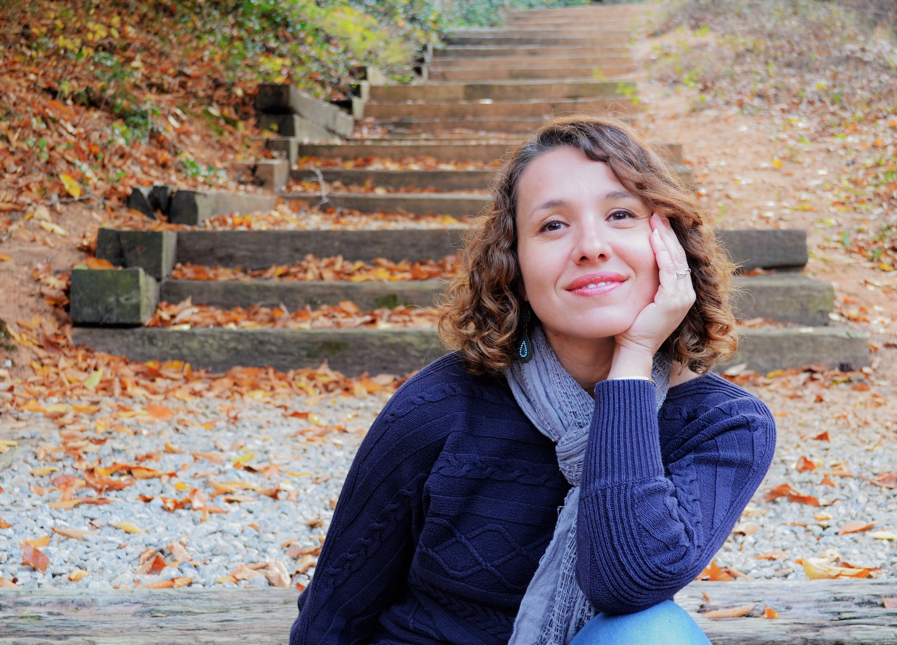
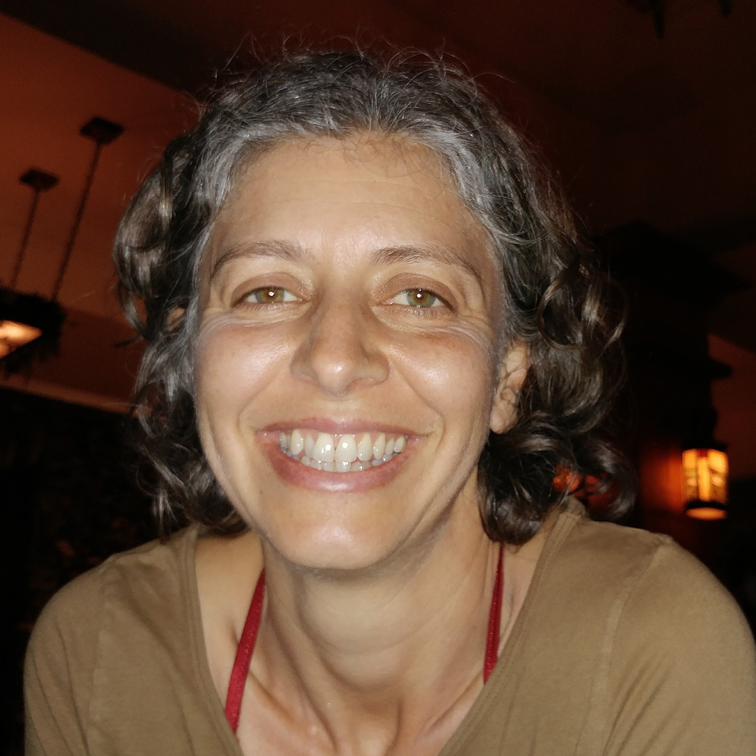
Led by Lucy MacGregor and Jelena Popovic. Lucy is a classroom teacher at Rainbow Community School, leads adventure based programs that empower young women, and offers mindfulness workshops, retreats, and communities of practice for educators in North Carolina and beyond. In her work Lucy combines her experience as a classroom teacher, her background in education and adventure based learning, and her training in mindfulness and yoga. She calls on the power of nature, storytelling, and the wisdom inherent within groups. Lucy is holds a B.A. in Sociology/Social Work and is an accredited Montessori teacher. She is a certified Children’s Yoga instructor and a certified Mindful Schools instructor, serving as a mentor for educators currently seeking Mindful Schools certification. She is honored to serve as the Mindfulness Consultant for Rainbow Institute. Lucy continues to be challenged, inspired, uplifted, and opened by her own journey through life, and is incredibly grateful to the entire community of beings travelling with her. * Jelena Popovic is a mom, peacebuilder, school psychologist, mindfulness practitioner and educator, as well as Mindful Schools mentor for their year-long certification program. She teaches mindfulness in preschools and schools, offers workshops and retreats, and facilitates communities of practice for educators across the world. In her teaching, Jelena combines her knowledge and background in neuroscience with a variety of mindfulness programs such as Mindful Schools, Relax Kids, and MindUp. Jelena has trained many educators across North and South America in the Relax Kids method and has led South Carolina mindfulness retreats for educators. She is currently a part of the Mindful Schools pilot program facilitating Mindful Educators Meetups in Greenville, South Carolina. Jelena is also on the leadership council for the international peace organization, The Peace Alliance, where she provides leadership on the best practices in Teaching Peace in Schools. Meet Jelena at her website www.poisedkids.net.

Rites of Passage: Integrating transformative, coming of age experiences into class culture and curriculum- Rites of passage are an integral part of an individual’s growth, validating their sense of self and their role within a society. Without such rituals of transition we can feel lost or isolated. And yet, when we fully undergo these sacred experiences of growth and change, our lives become more fulfilling. This workshop will delve into the importance of Rites of Passage, not only in general society, but for a student learner in a school setting specifically. We will explore the elements common to all Rites of Passage and share how we at RCS implement this universal structure into fundamental aspects of our holistic educational experience.

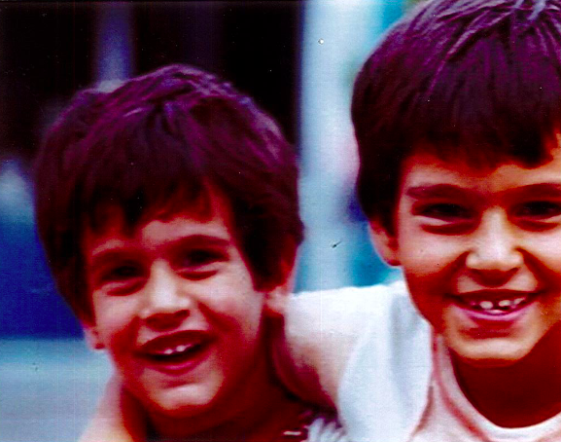
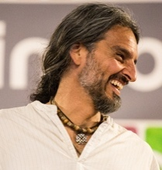
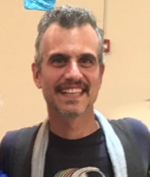
Led by brothers Justin Pilla and Jason Cannoncro. Justin, RCS’s Creative Director, has been able to incorporate his artistic skills in various venues, most notably as facilitator for Imagine, the immersive arts experience at Rainbow. This has allowed him to merge his passions for the arts and his joy for working with children. He has been mentoring youth in various capacities since way back in the ‘90’s. He uses myth, art, and storytelling to inspire children to explore their world and themselves. Justin is a musician, game designer, and myth spelunker.* Jason is an Omega Middle School teacher and a RCS Seven Domains™ Master Teacher. While enjoying the mutual exchange of ideas during classroom discussions, Jason nurtures the development of wisdom from knowledge gained. He incorporates traditional storytelling and nature studies into all of his lessons. By exploring the ‘big ideas’ and bridging the gap between information and application, Jason presents students with tools that may be used upon their journey. It is important to him to form strong connections with each of his students, doing so through patience, respect, and creativity, so that he may be able to encourage their gifts while they discover their own path.

Beyond Mathematics and Linguistics: Blending the spiritual and mental domains- In this session we will explore how the social, emotional, and spiritual domains can be seamlessly woven into any English and Math curriculum. We will be highlighting both writing, reflection, and language arts routines as well as the tool, techniques, and power of sacred geometry.

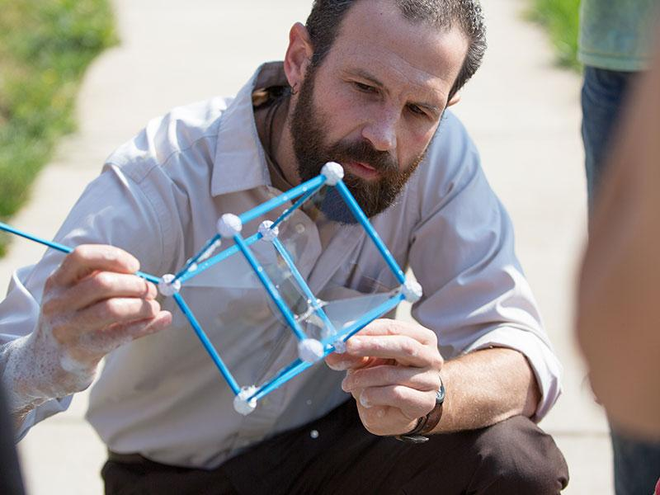
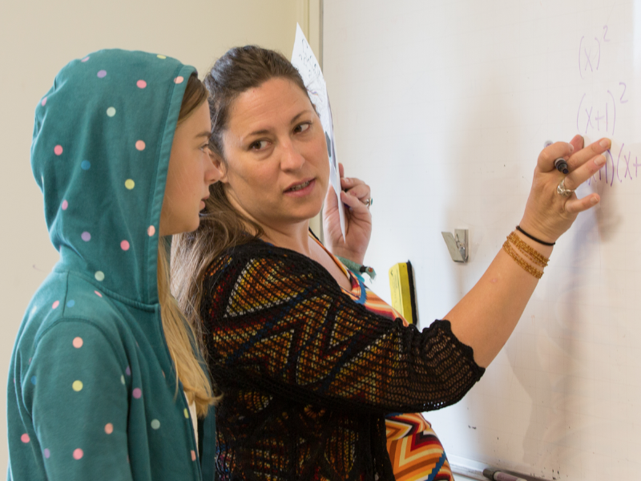
Led by Susan Waddell and Mark Hanf. Omega Program Coordinator and Lead Teacher, Susan Waddell, has taught in the Omega Program since 2006. Prior to moving to Asheville, she spent three years teaching language arts and math in middle schools in Houston, Texas. Susan holds a Bachelor's Degree in English with an emphasis in creative writing from Elon College, has her teaching certificate, and obtained a Master’s degree with a focus on Curriculum and Instruction in the Middle Grades from Gardner-Webb University. * Mark Hanf is Omega’s Sacred Geometry and Polymath teacher as well as Omega’s Assistant Teacher. Mark uses sacred geometry as an innovative approach in his teaching. When Mark isn’t at Rainbow, he’s busy promoting an incredible game he created called the AT Board Game. Mark is proud of having hiked large sections of the Appalachian Trail and can’t wait to share his unique perspective of holistic education with you.
Mindfulness and Movement: Ground learning in the body by weaving mindful practice into active learning- In this workshop participants will learn tools on how to incorporate mindfulness within the physical domain. Mindfulness takes many forms during active movement. Come away with strategies to connect mindfulness concepts to game play, recess, and competition to help foster good sportsmanship and respectful behavior and language during the educational process.

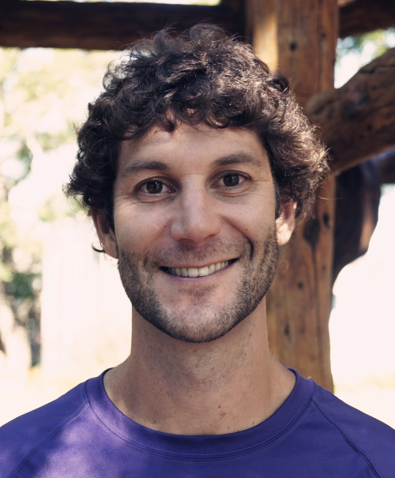
Led by Mark Strazzer. Mark is the RCS Athletic Director and Physical Education teacher. He graduated from the University of Delaware with a degree in Health and Physical Education and earned a Master’s in Health Education from East Carolina University. For 13 years he has taught middle and elementary health and physical education in Asheville, Ghana, and India. He has also spent time as a personal trainer, a diabetes counselor, and a tobacco prevention coordinator. Additionally he serves as RCS’s hospitality league’s coach.
Leading With Compassion: Techniques that empower compassionate collaboration among teachers, families, and students- In this workshop we will explore techniques that empower our families and students to collaborate with the classroom teacher and one another in order to create a nonjudgmental, welcoming climate and culture. We will also foster conversations that give rise to the benefits of facing one another with honesty and trust. We will explore both theoretical and practical methodologies that embraces the "why’s" and "how’s” of mindful and empathetic interaction. Specific attention will be paid to Nonviolent CommunicationSM pedagogy and practices, along with other rituals that directly align with the mission of Compassionate Communication.

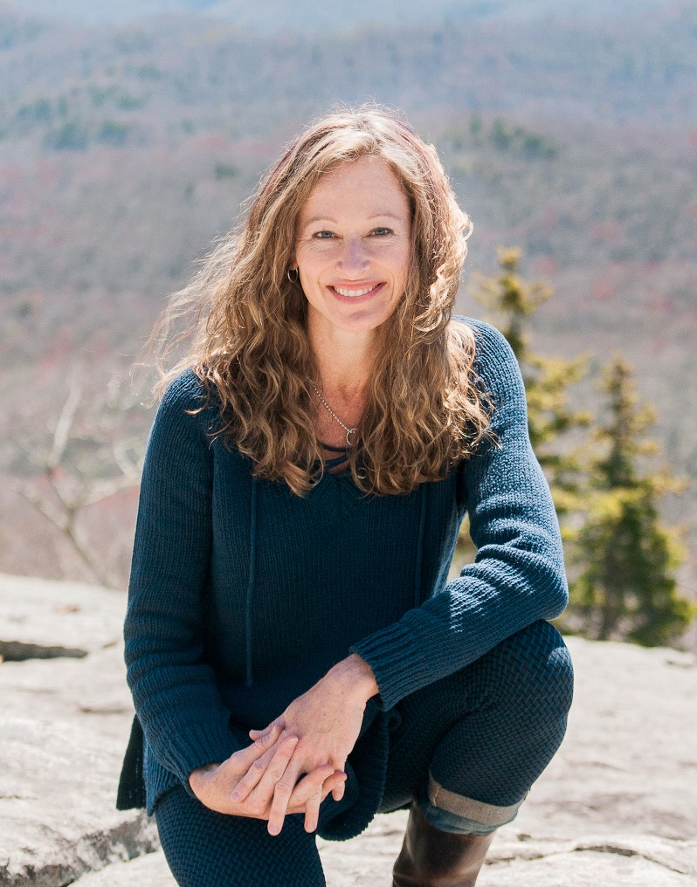
Led by Susie Fahrer and Courtney Morrison. Susie is Dean of Faculty and Rainbow Community School 4th grade teacher. Susie has degrees in both Elementary and Special Education, which have allowed her to serve in various positions and multiple settings in her professional career. She is highly invested in holistic child-centered education and seeks to engage the Rainbow Seven Domains™ inside and outside of the classroom. * Courtney Morrison is a RCS Parent Council Representative, a Holistic Massage Therapist for Women, and a Conscious Communication Life Coach. She has been studying holistic living since 1989. As a licensed massage therapist and a certified life coach with a degree in Holistic Health, she has facilitated communication classes, groups, private sessions, and workshops over the past five years.
The Art of Environmental Design in Holistic Education- Environmental design strives to create an ecology or “home” for learning to support human health and growth; an environment where we can imagine the whole, while understanding levels of interaction from the largest to the smallest dynamics. Teachers and students respond continuously through the physical senses to their surroundings of light, color, shape, temperature, surface texture, sound, moisture, odor, and electromagnetic fields. The body and mind interact creating physical response, emotion, thought, transcendence, and more. In this presentation we will review the renovations and new construction at Rainbow Community School campus as a starting point to explore the environmental design approach. We will review evolving technologies as well as simple solutions to improving the interior environment and its connection with the natural outside world. As the surrounding environment elevates all members of the school community with beauty and resources, in the well-designed school, teaching can more easily become a practice in art to create a living curriculum in their very midst.
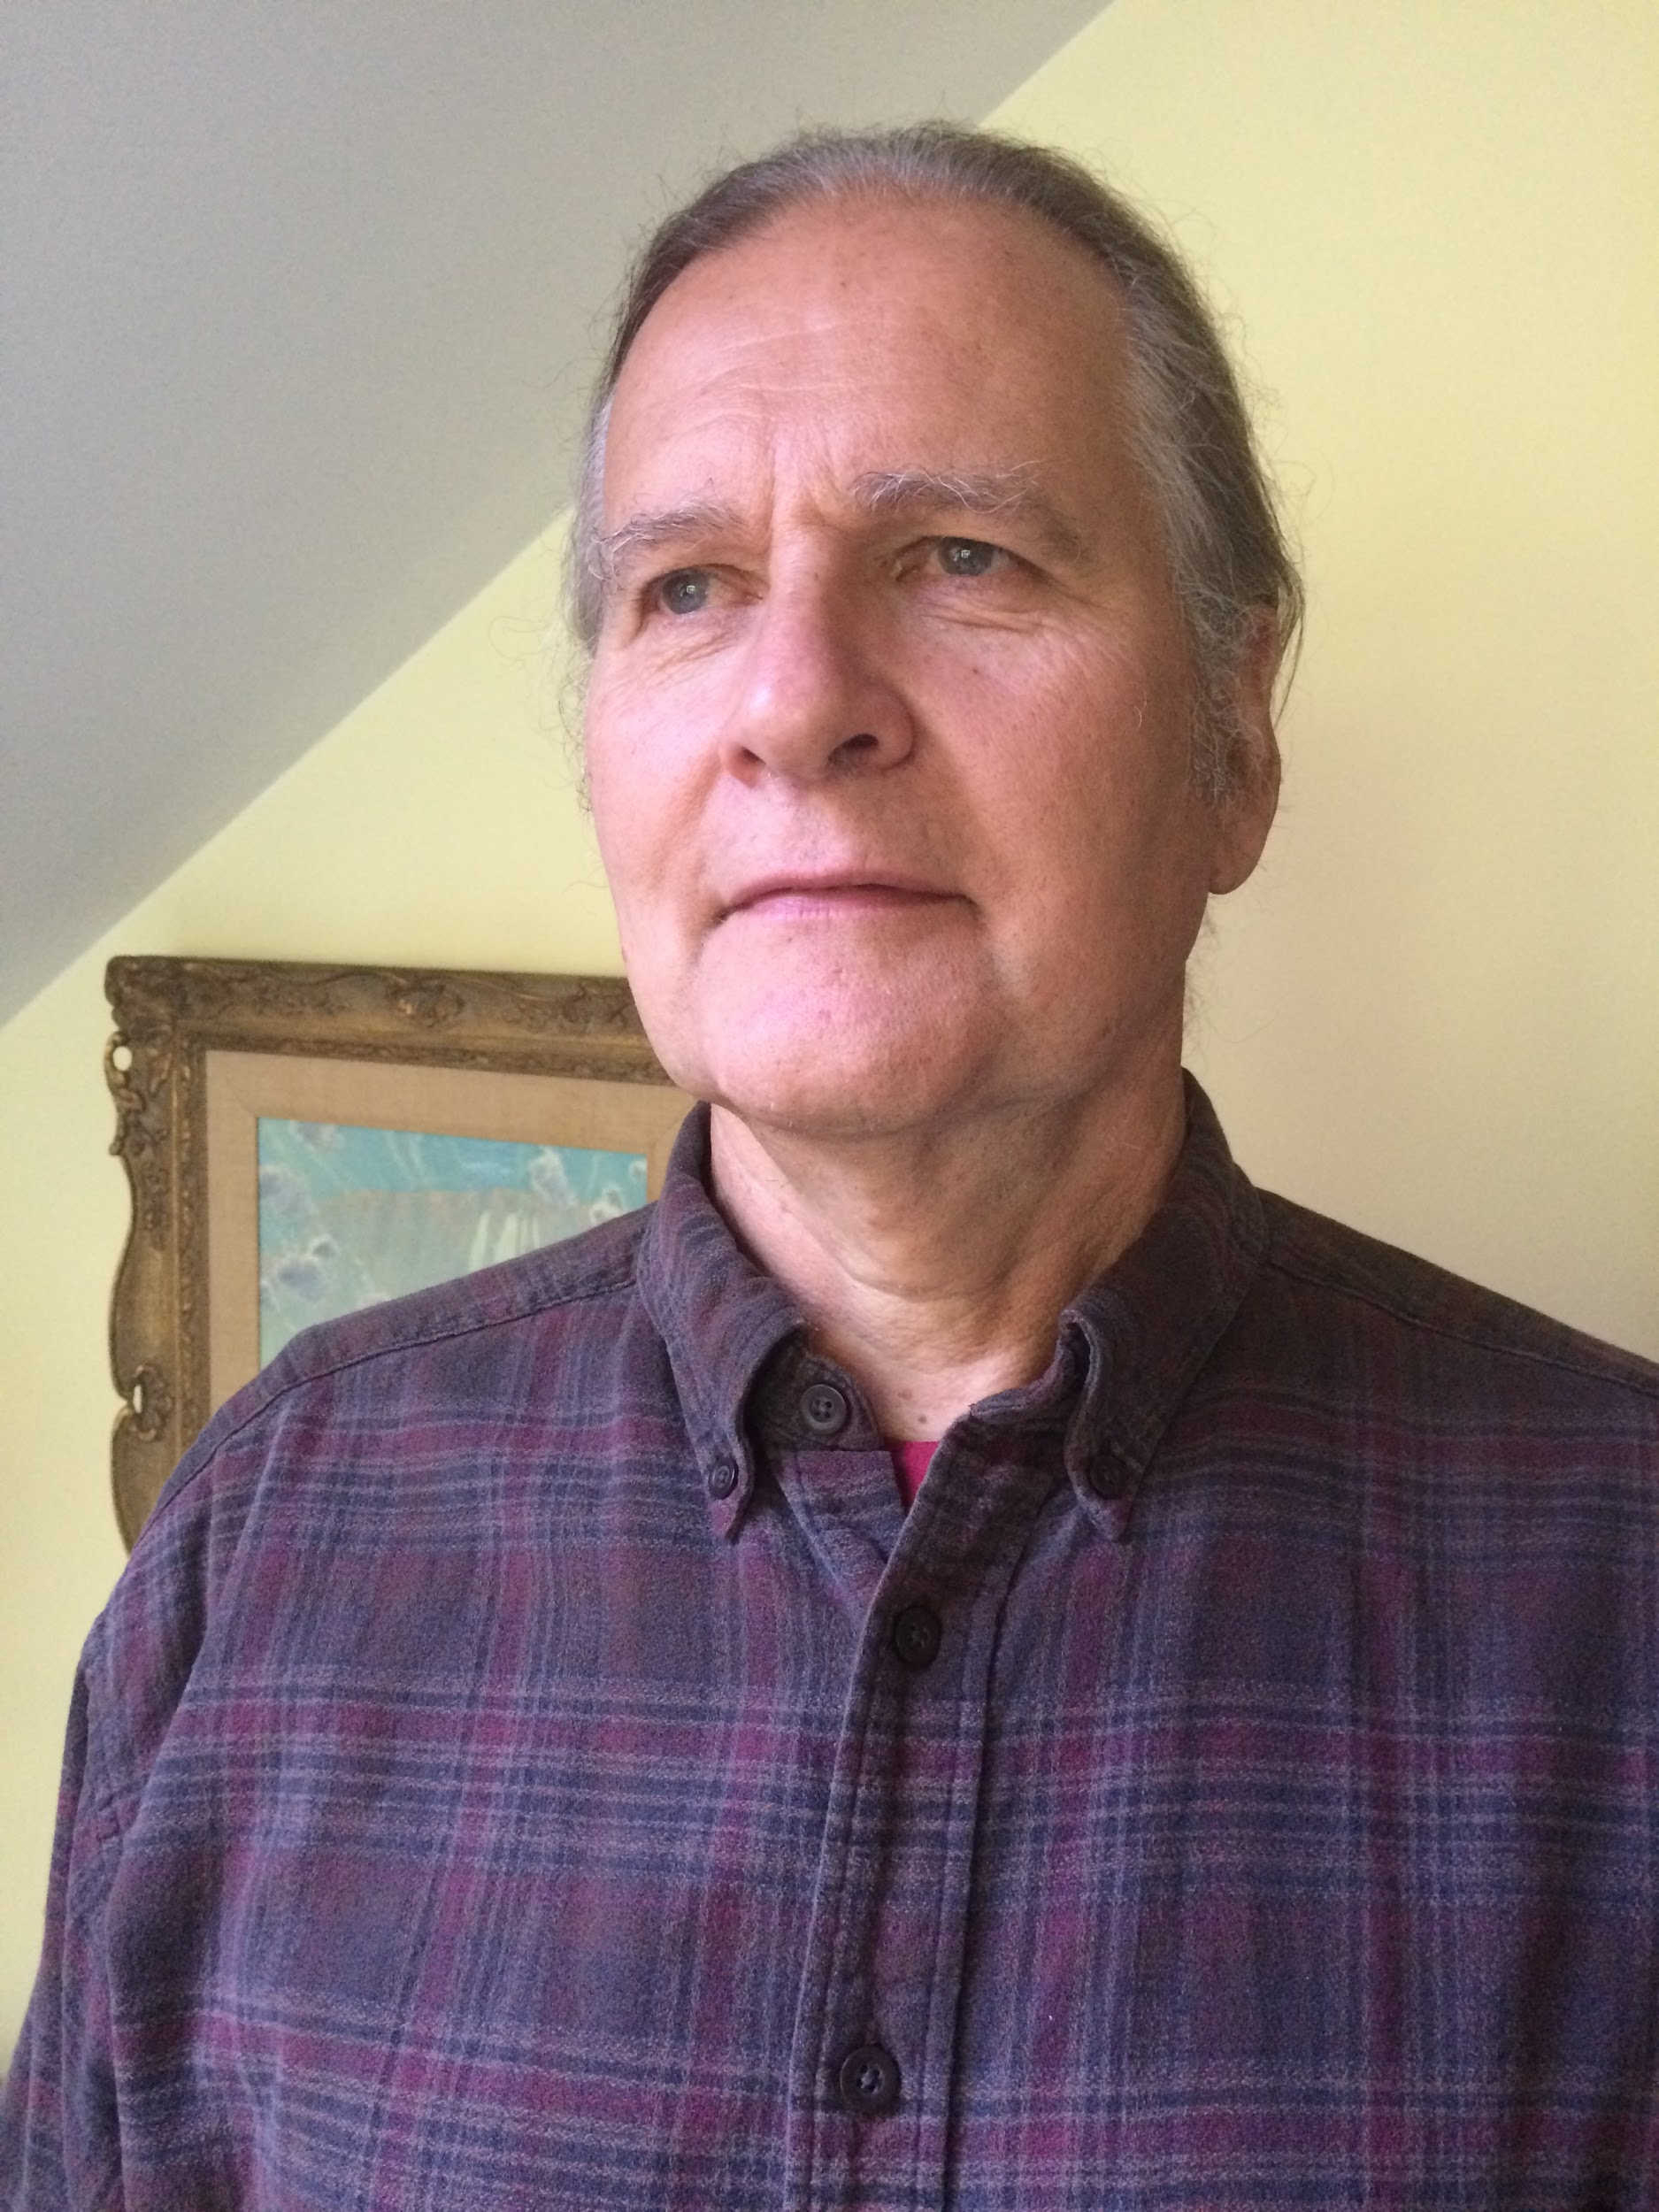
Led by Greg Olson. Greg is an environmental designer and educator by practice. He holds a PhD in Education from Duke University with a focus on facility planning and a dissertation entitled “Passive Solar Design for Energy Conservation in Schools”. His studies include environmental effects on behavior and learning in the classroom. He has served as faculty at the North Carolina Center for the Advancement of Teaching and directed the Alternate Energy Technology Program at Southwestern Community College. He serves on the faculty at University of North Carolina at Asheville, where he teaches “Environment, Design, and Solar Energy”. Greg was also the design leader and project supervisor for the renovation of the Rainbow Community School campus in the late 1990’s, which included upgrading the historical home, constructing the elementary classroom building, and incorporating passive solar design and radiant floor heating. Since the 1980’s Greg has designed over thirty environmental homes throughout the mountain region.
Theater as a Transformative Practice: Image and applied theater in the classroom- The possibilities of dramatic play, embodied ritual, and creative self-expression are endless! In this workshop we'll explore how to begin incorporating moments for 'applied theater' in your classroom. It's surprising how easily children can relate to their real-life conflict through make-believe theater exercises and how effective a tool theater can be in fostering empathy, solving problems, and building collaboration. The best part is that theater exercises are extremely versatile and can be fluidly incorporated into academic unit lessons, social-emotional learning, transition times, and centering practices. Schools of applied theater we will be discussing include Theater of the Oppressed, Playback Theater, and improvisational theater. Join us for a hands-on workshop aiming to equip you with the beginner director’s tools to cultivate in your students a healthy, playful, and compassionate sense of self and community.

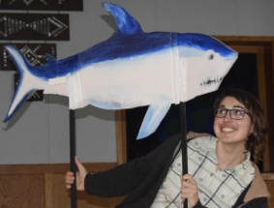
Led by Ange Moore. Ange Moore recently moved back to their native San Francisco Bay Area after having taught Spanish, theater, and gender studies here at Rainbow Community School. They are so excited for this opportunity to share with you the power theater has to evolutionize our systems of political organizing, education, and healing. Having completed their BA in Decolonization through Theater Ange is now going back to school to pursue a Master’s degree in Drama Therapy which will allow them to apply theater to even broader contexts. Contact angela.moore@rainbowlearning.org with any questions or considerations regarding applied theater.
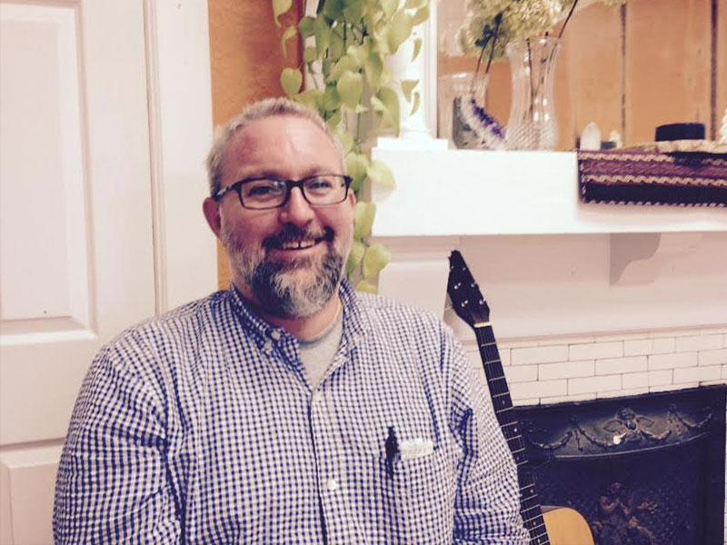
Inner Alchemy- This workshop will center around direct experiential practices. We will be engaging in two short meditations – one, a horizontal practice, the other, vertical. Each will be between 15-20 minutes in duration. From within your own experiences, elicited from these exercises, we will be directly exploring the Rainbow Seven Domains™ model. Seeing for ourselves through ourselves; how we each experience the world through different lenses, different domains, both narrow and broad. Through personal writing, journaling, and personal sharing of narrative, we will begin the Alchemist's journey of exploration into the Self. We will begin an "unpacking" of different models of consciousness which seek to explain and help us in understanding what it is that resides under the surface of our seeing, feeling, thinking, and doings. A mapping of consciousness, of the interior, crucial to the Alchemist's journey. A coming to know thy Self.

Led by RCS’s Director of Counseling, Will Ray.
The Art of Storytelling and The Hero’s Journey- Come join us for a fun session designed to bring back the sacred art of storytelling to the classroom. Learn how the ancient act of gathering for fellowship around the fire can lead to relevant learning in all classroom settings today. Children young and old can be inspired by story to understand history, gain perspective of the diverse human condition, experience gratitude for the magic and science of the natural world, and much more. Explore a classroom curriculum designed around: The Hero’s Journey! Discover how students can recognize personal transformations in their lives, acknowledge and embrace the unknowns ahead of them, and realize the hero within themselves. Through mythologies old and new, we discover archetypes that may be paralleled in our own students’ struggles and successes, setting a platform for growth and resiliency.

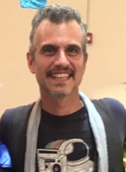
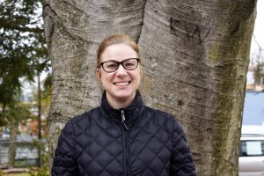
Led by Jenny Armocida and Justin Pilla. RCS 6th grade lead teacher, Jenny Armocida, has over ten years of classroom experience in holistic education settings. She emphasizes project-based and experiential learning in her classroom. She is a certified yoga teacher and enjoys sharing mindful movement with her students. * As Creative Coordinator, Justin has been able to incorporate his artistic skills in various venues, most notably as facilitator for Imagine, the immersive arts experience at Rainbow. This has allowed him to merge his passions for the arts and his joy for working with children. When he is not expounding academic concepts or expanding the minds of youth, Justin enjoys conjuring music, sojourning in nature, designing board & card games, and myth making.
Awakening a Deep Nature Connection: Exploring the Magic and Mystery of the Natural World-
In this day and age an understanding of the human impact on the environment is virtually impossible to ignore. Likewise these environmental problems impact our daily lives and will continue to do so for generations. At RCS we believe that environmental stewards are birthed from a learning atmosphere that sees nature as sacred and divine. The culture, climate, and programming at RCS aim to nurture within the formative years of childhood an intimate and empathetic bond with the natural world that will grow over time into meaningful and enduring environmental action. In this workshop we will investigate rituals and activities that help infuse a love, appreciation, and reverence of the natural world into our lesson plans and classroom culture even for our “littlest” learner, setting a primary stage of development for lifelong environmental stewards.

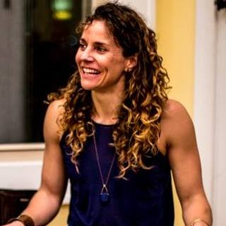
Led by West Willmore. West is Rainbow Seven Domains™ Master Teacher, RCS Curriculum Director, RCS resident naturalist and Rainbow Institute’s Director of Operations. West’s educational philosophy is anchored in place based and experiential learning. She works to nurture a love of learning by fostering in students deep connections to themselves, their community, and the natural world around them. She strongly believes that direct, authentic, and meaningful experience is the primary stepping stone to understanding.
Mindfulness of Mind and Body: Bolstered resilience through somatic awareness- In this workshop we will explore the mind/body connection by focusing on mindfulness of body. Our bodies are constantly giving us information that is unique from the perceptions of our cognitive mind and our interpretations of reality. Our mind may tell us that we are angry, but in our bodies we may be trying to stay safe from perceived threat. Sometimes feeling sensations allow us to discover what we did not know was there, and for our students noting sensations in the body allows for a somatic awareness that is frequently lost in the pace and values of our society. Teaching students somatic awareness teaches a different kind of self-awareness, one that both empowers and builds resilience.
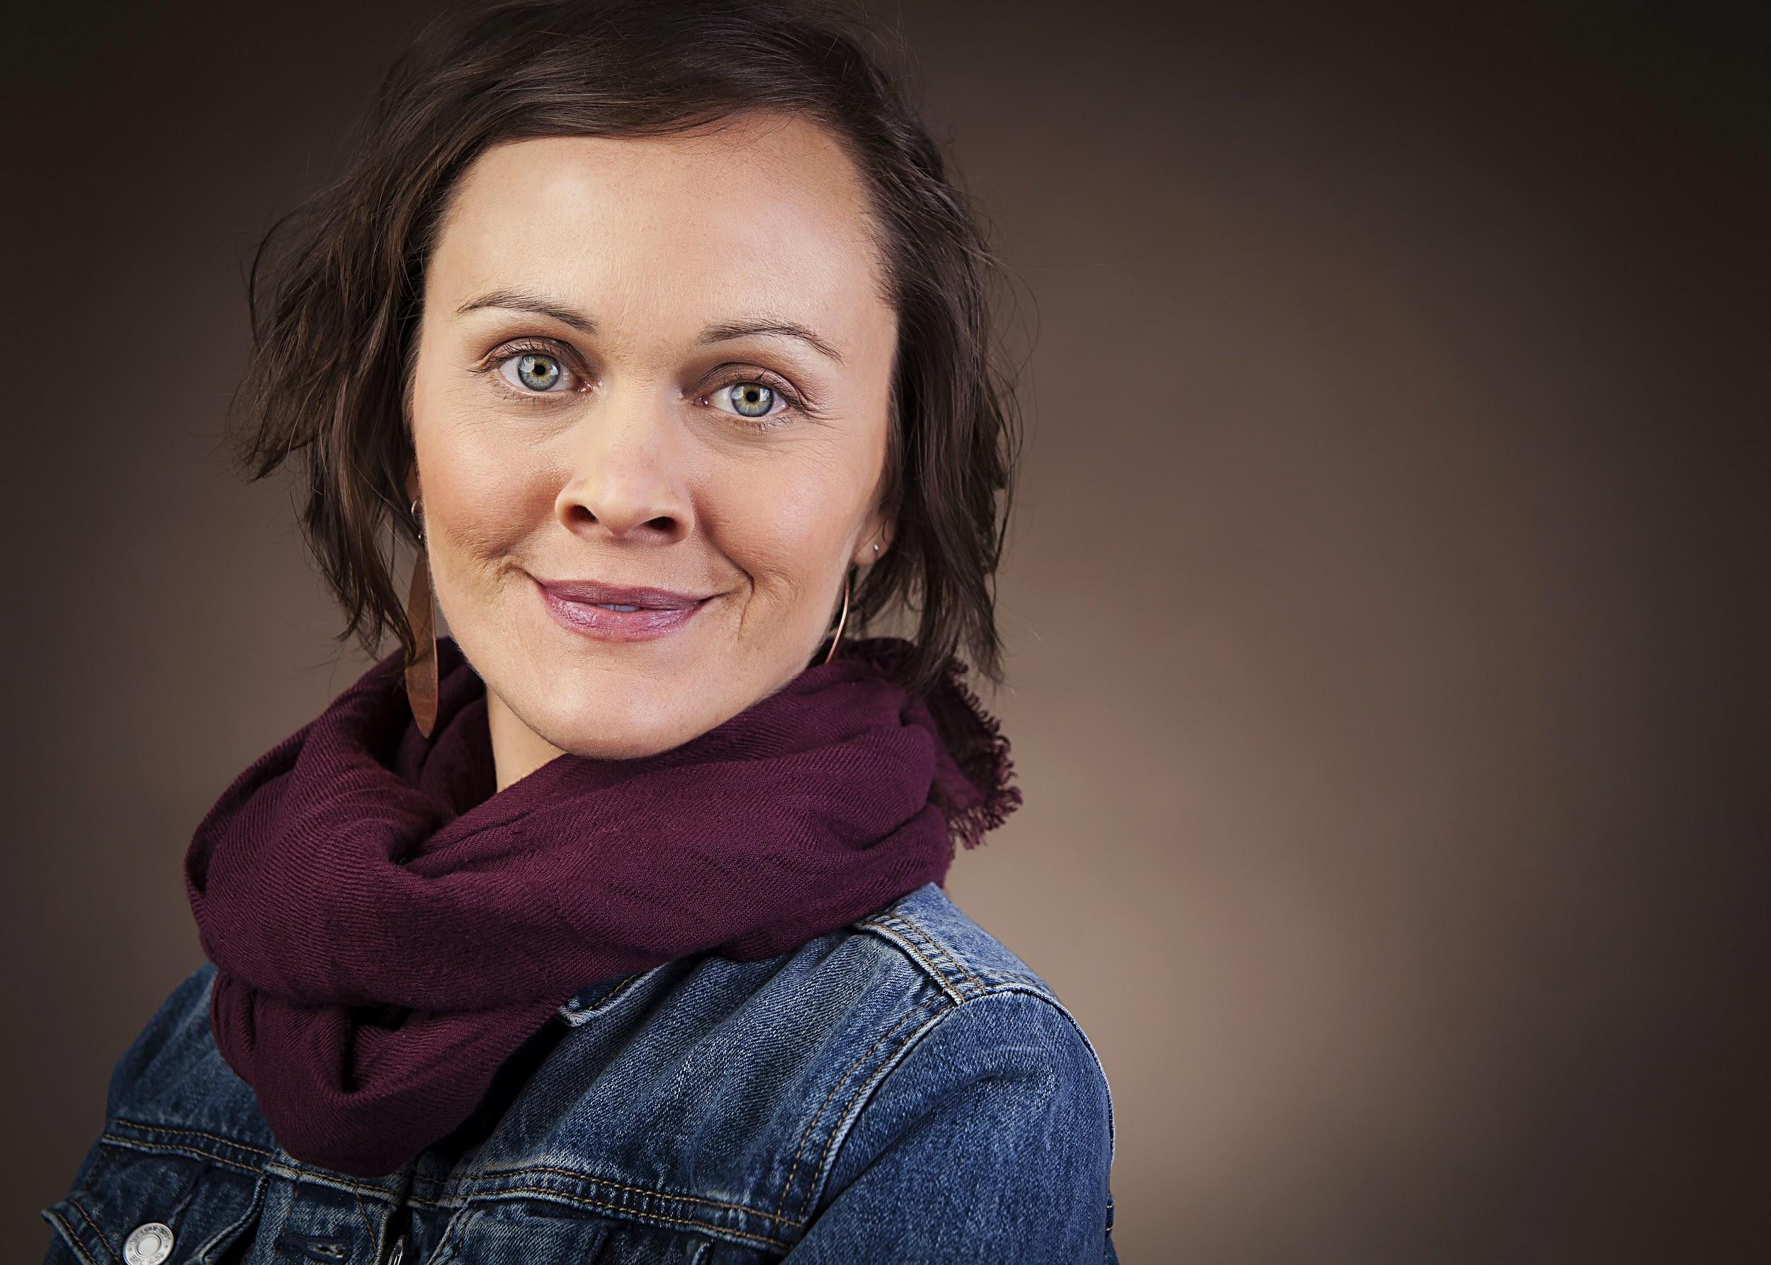
Led by Sarah Shoemaker. Sarah is the Academic Director for the Black Mountain Academy and creator of Embodied Breath LLC, a mindfulness-based consultancy for schools, families, and women. Sarah has worked as an educator and school administrator through various schools, from public to clinical and residential, and maintains that whole-child wellness be a central consideration as we raise resilient children. Sarah is a 2017 graduate of the Mindful Schools Year-Long Certification and is pursuing next steps in a career path in trauma-informed healing practices.
There is No Mindfulness Without the Heart: Sufi perspectives on awareness, love, and the message of unity- Parents along with education and healthcare professionals most often conceive of mindfulness as essentially limited to a cognitive function of the brain. When deeply considered mindfulness is actually seen to be just one aspect of a fully developed and enlivened heart. The spiritual tradition of Sufism carries profound insights into the nature and maturation of the heart, both psychologically and spiritually. Participants in this seminar will have the opportunity to experience some of the Sufi practices that bring healing, peace, and divine connection to the heart.

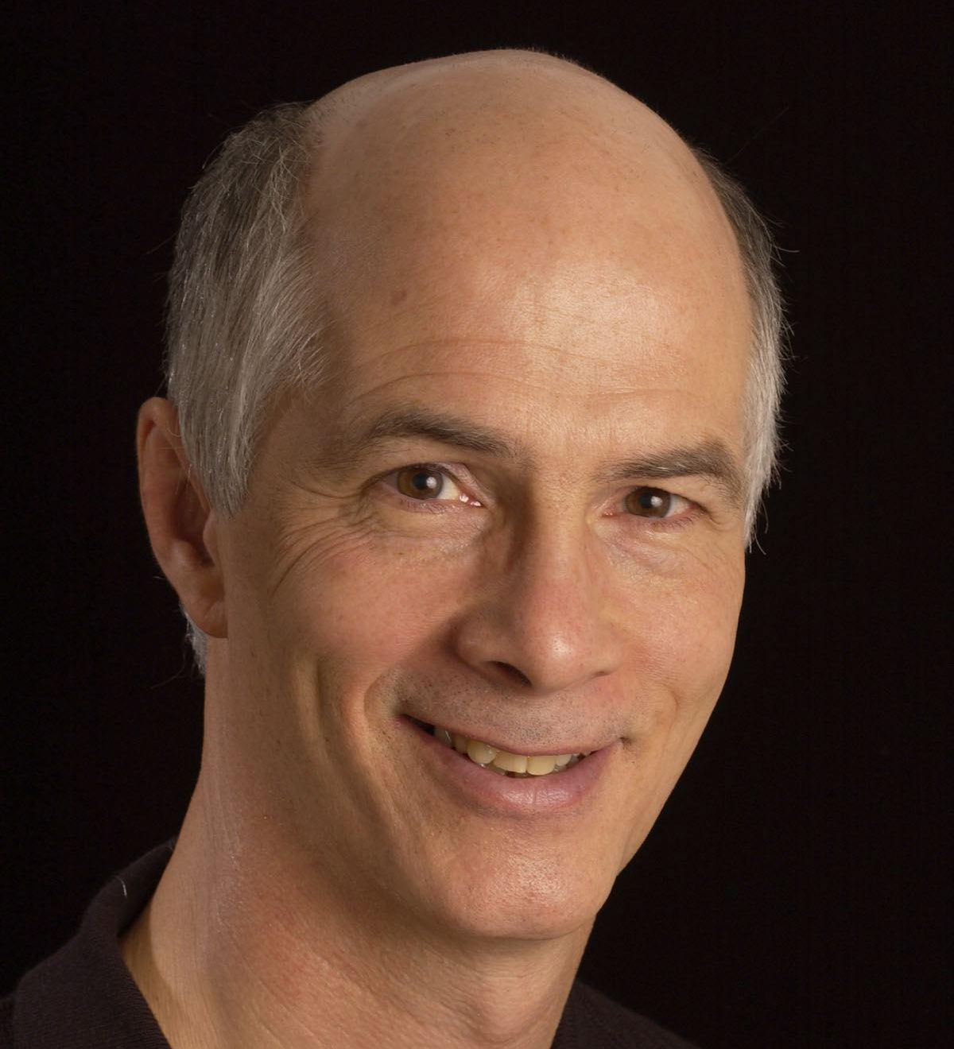
Led by Dr. John Laird. Dr. Laird is founder of the Great Smokies Medical Center and Co-Founder of the Great Smokies Diagnostic Laboratory (now Genova Diagnostics). He practiced integrative and holistic medicine in the Asheville area for 17 years. Dr. Laird was responsible for the passage of landmark 1994 NC legislation legalizing the practice of alternative medical therapies and physicians. He has been a student of Sufism for forty years and currently directs the Shafiyy Institute of Health and Healing in Napa Valley, California.
MINDFULNESS & RACE PT 1: The Creation of Whiteness- The current way in which we understand race and racism is flawed… and historically incorrect. As a result the ways we talk about and teach race in our schools, both directly and indirectly, are failing our students. In this workshop we’ll shift the paradigm of race and racism and get in touch with our own stories of who we are, so that we can become better and more mindful anti-racist teachers.

MINDFULNESS & RACE PT 2: HOW WE SHOW UP? How do we as educators perpetuate the institutional and structural systems that cause the achievement gap? In this workshop we will explore how implicit bias and other stressors show up in our personal interactions and brainstorm ways we can maintain mindfulness and interrupt those impulses.

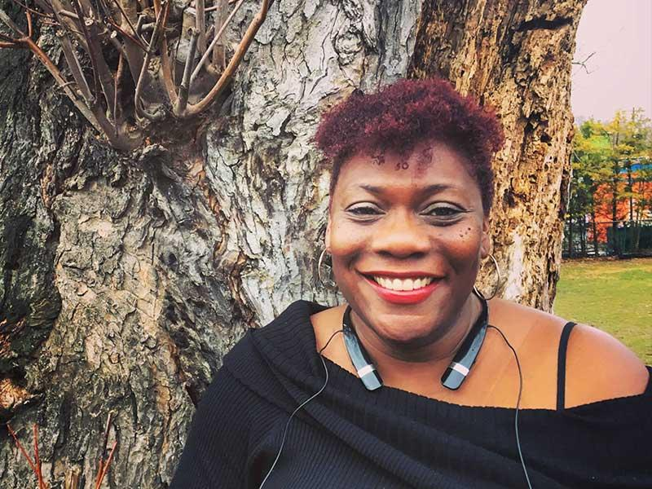
Led by Danae Aicher. Danae Aicher is the Equity Director at Rainbow Community School and co-chair of Building Bridges of Asheville, an Asheville-based anti-racism organization. She comes to equity and social justice work after two decades of being a political journalist, a political operative, and then a very political at-home Mom. And it’s that last role that pushed her into this work. In her pre-Mommy professions, she saw up close (and behind the scenes) the ways in which equity wasn’t present and the ways in which we, as a society, maintain and perpetuate inequity. She says she wants a different world for her children.

How does Heart-Centered Education Impact our own Lives? Come participate in Rainbow-specific experiential exercises that are designed to open the heart and lead to healing and transformation. These exercises can not only impact how you are with children, but also enrich your own life and your relationships with others. Ultimately, when we open and deepen our hearts, we carry and transmit more peace and love as we serve others.

Led by Nura Laird. Nura, formerly known as Ashrita, was one of the original founders of Rainbow Community School in 1977, known then as Rainbow Mountain Children's School. She has been an educator in public and alternative schools since the early 1970's. She co-founded both an alternative secondary school in Vermont before Rainbow, and more recently the University of Spiritual Healing and Sufism in Northern California. Nura has been a lifelong advocate for children and a parent educator and coach. She spearheaded a formal research study in spiritually-based parenting and family healing which became the PhD dissertation of one of her students. Nura is also a mediator with extensive experience in family mediation and a number of counseling modalities. She works mostly with couples and family members to resolve conflict and restore love and harmony to families. For the past 40 years Nura has been a student of Sufism, the age-old Islamic mystical path of wisdom and love. Currently Nura is a professor of Sufism, spiritual healing, and peacemaking at the University of Spiritual Healing and Sufism in northern California. She teaches internationally and has a private healing practice in St. Helena, California, working both in person and remotely by phone or online.
Learning Through a Holistic Lens: Exploring how teaching the whole child enhances the learning path of all children- In this workshop we will engage the Rainbow Seven Domains™ learning model and explore how teaching the whole child can not only positively and powerfully impact students with diverse learning needs, but also enhance the learning path of all children. This learning model is the foundational structure through which RCS approaches all learning and teaching. The model yields many strategies, lessons, and activities to engage children of all ages in facing their challenges, while reinforcing their strengths and self-concept.

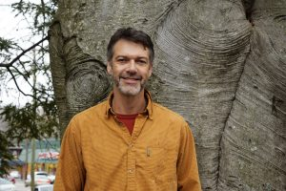
Led by Eddy Webb. Eddy is an award-winning Rainbow Seven Domains™ Master Teacher. He seeks to inspire his students with his own enthusiasm for life and learning, modeling risk-taking and mindful reflection. His goal is to make learning a fun adventure for his class with lots of real-world experiences and time in nature, while embracing a holistic and project-based learning approach. He also plays the guitar and sings with children every day, instilling the idea that we can all be active participants in life and make the world a better place by sharing a song or whatever gift we have to offer.
Creating Sacred Space with Secular Ritual- What is the purpose of ritual in contemporary life? What place does it have in a secular school? How can it be implemented in a non-religious manner? As seasoned leaders of Rainbow Community School, Renee and Sandra have been facilitating ritual for children and adults at Rainbow for over ten years. In this session we will discuss how ritual can create a culture of reverence that supports mindfulness. The basic elements of ritual will be taught and participants will each have the opportunity to craft a ritual that they can implement within their own classroom, home-life, or workplace.

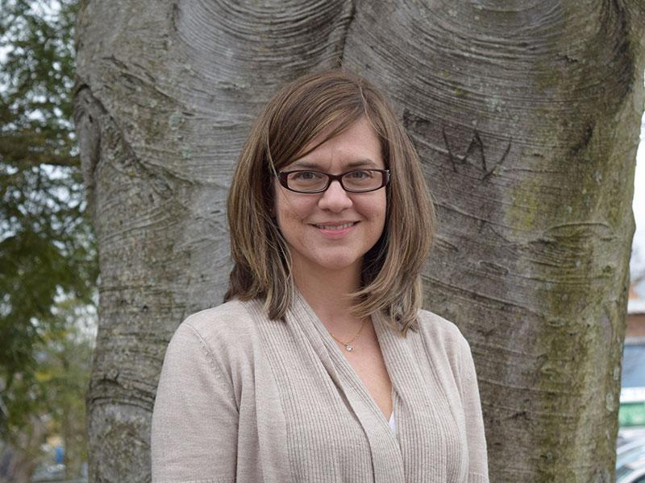
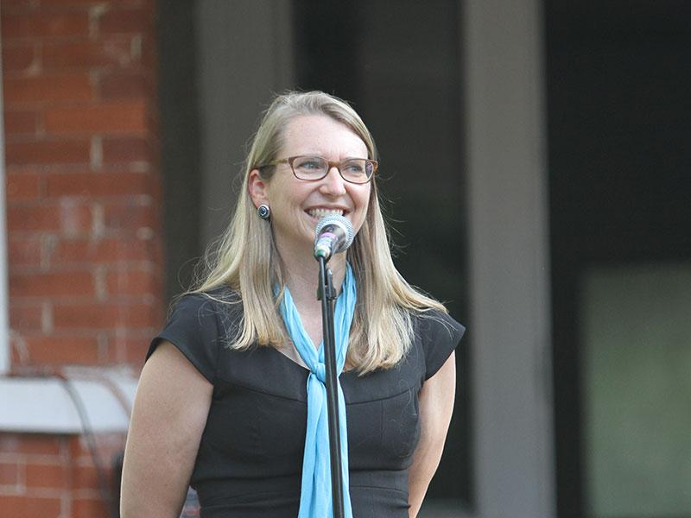
Led by Renee Owen and Sandra McCassim. Renee Owen is passionate about educating children and adults to be mindful humans. As Executive Director of Rainbow Community School since 2007, she has witnessed the miracle of an education that includes mindfulness and secular spiritual practices embedded in children’s daily lives. Renee is also co-founder and CEO of Rainbow Institute, the newly formed adult education organization dedicated to training teachers, therapists, and parents on how to include mindfulness and other secular spiritual practices into their classrooms and lives. She is a doctoral candidate at Columbia University’s Teachers College, and her extensive research is on secular spirituality in education and spiritual development from childhood through adulthood. * Sandra McCassim, RCS Operations Director, values a strong school community and sees the school as not just an environment for students to learn but a community for families and staff to grow and learn together. Sandra has held many positions at Rainbow and has been a classroom teacher across multiple grade levels. Sandra is currently Rainbow’s Director of Operations and although she loves overseeing the daily operations and functioning of the school, she’s excited about this opportunity to share her experience of spiritual classroom teaching with other passionate educators.
The Heart of Learning: A 90 minute dialogue with John Johnson, M.S., Th.D.- In this workshop we will examine pros and cons of particular aspects of holistic education including student led assessment, integrating an inner-world outer-world approach to learning, the place of spirituality in the classroom, and useful learning skills to cultivate in our life-long learners.

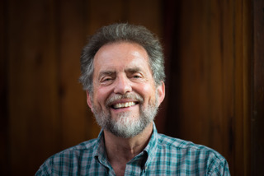
Led by John Johnson, M.S.,Th.D.. John was a pioneer in the establishment of holistic education in Western North Carolina. John organized the first regional and state conference on holistic education in North Carolina at the Owen Conference Center at UNC-A in 1979. He helped in the founding of Rainbow Mountain Children’s School and was its executive director and curriculum director for nine years (1990 – 1997). Under his direction the school grew from a pre-k through second grade to a pre-k through eighth grade school. He seeded the school with the holistic curricular approach that supported what it has become today. John went on to help found Odyssey Community School (a pre-k through twelfth grade charter school) and was headmaster of OCS for its first seven years (2007 – 2014).
“Breathing In, Breathing Out” Meaningful Song, Movement and Rhythm in the Classroom- Research has found that learning music facilitates the learning of other subjects and enhances skills that children inevitably use in other areas. “A music-rich experience for children of singing, listening and moving is really bringing a very serious benefit to children as they progress into more formal learning,” says Mary Luehrisen, executive director of the National Association of Music Merchants (NAMM) Foundation, a not-for-profit association that promotes the benefits of making music. This is an experiential and fun workshop. As participants you will be given ideas and tools to incorporate rhythm, movement, and song into your classrooms or homes. You are encouraged to bring a recording device. You will also walk away with a songbook of songs tried and true that express the truth and beauty of our world.

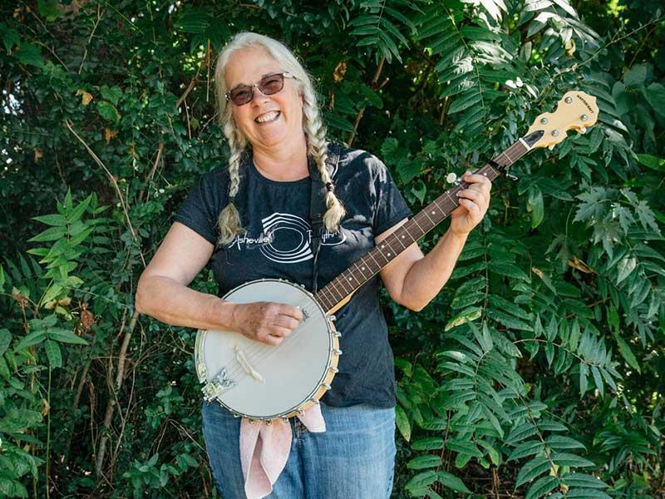
Led by Sue Ford and Eddy Webb. Sue, our award-winning RCS music teacher, became a “folkie” while immersed in regional music at Appalachian State and Warren Wilson College. Sue continued to study and perform an eclectic blend of musical enterprises including African drumming, dance, marimba and balafon, music history and theory, songwriting, composing, guitar, banjo and cello playing. Sue Ford’s professional activities include serving as assistant director of “Womansong” for seven years, directing the EMBE Marimba Band and Chikomo Marimba, presenting workshops and performances for teachers at the National Expeditionary Learning Conference, the National Orff Association Conference, the National Children’s Music Network Conference, and the NC Charter School Conference. * Eddy is an award-winning Rainbow Seven Domains™ Master Teacher. He seeks to inspire his students with his own enthusiasm for life and learning, modeling risk-taking and mindful reflection. His goal is to make learning a fun adventure for his class with lots of real-world experiences and time in nature, while embracing a holistic and project-based learning approach. He also plays the guitar and sings with children every day, instilling the idea that we can all be active participants in life and make the world a better place by sharing a song or whatever gift we have to offer.

The Heart of Diversity: Bringing compassion and mindfulness into diversity and inclusion-
Omi has sat in numerous talks of equity and diversity, and she has trained in one of the best diversity and inclusion programs in the country, and yet there is something that disturbs her, namely the absence of the talk of the heart and compassion. Yet research and experience show that compassion and mindfulness training open the heart up and help individuals of all ages experience and connect to a sense of true oneness, harmony, and joy. We are thereby more able to embrace diversity more and to co-create a peaceful and whole world. In this workshop we will soften into powerful compassion concepts and engage in mindfulness exercises that enhance diversity work and nurture heart-based leadership in our schools, communities, and selves. "If you don't bring the question of the heart into things, you will always be putting out fires."

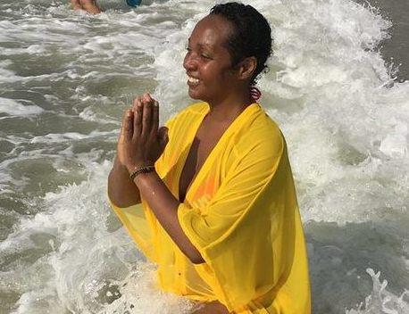
Led by Omileye Achikeobi-Lewis M.Ed, NCC, LPCA. Omi is an international award-winning author of several books, former national UK journalist, fifth generation Wisdom keeper, storyteller, and sacred artist of Afro Caribbean roots. A mother of two she is also a licensed contemplative clinical mental health psychotherapist, a licensed school counselor, a trained SEED Facilitator, and an inclusion and diversity consultant. She, along with her husband, have co-founded several organizations and projects: YeyeOsun, the Institute of Compassion and Wisdom in Action; renown international Humanity for Water Awards; and UNICEF Interfaith WASH Alliance (founded with other world and cultural leaders). Her work has been recently blessed and recognized by His Holiness the Dalai Lama and Kuten La, the Tibetan State Oracle. Omileye has also received several ancient distinguished African spiritual titles and roles, is the award winner of the prestigious Prince's Trust Award, and has a passion for working with children, diversity, and the environment. She has just founded her own private integrative and contemplative diversity counseling practice and consultancy.

Creating Heart Spaces for Learning: The brain science of mindfulness, compassion, and learning- In the midst of competing demands on our time, attention, and capacity to care, how can we guide our students (and ourselves) toward the place where our “deep gladness and the world’s deep hunger meet?” (Frederick Buechner). This is an important process through which we discover work that replenishes our spirit even as it serves others. When the speed of our lives causes us to overlook opportunities for joy, connection, and meaning we may rush past opportunities to meet the world’s needs, as well as our own. In our time together, we will focus on the foundation of service beyond the classroom - slowing down enough to notice what is needed and caring for ourselves and others. During this workshop we will experience the effects of slowing down and noticing through experiential activities, all of which can be shared with your students, clients, and children.

Led by Lucy MacGregor and Jelena Popovic. Lucy is a classroom teacher at Rainbow Community School, leads adventure based programs that empower young women, and offers mindfulness workshops, retreats, and communities of practice for educators in North Carolina and beyond. In her work Lucy combines her experience as a classroom teacher, her background in education and adventure based learning, and her training in mindfulness and yoga. She calls on the power of nature, storytelling, and the wisdom inherent within groups. Lucy is holds a B.A. in Sociology/Social Work and is an accredited Montessori teacher. She is a certified Children’s Yoga instructor and a certified Mindful Schools instructor, serving as a mentor for educators currently seeking Mindful Schools certification. She is honored to serve as the Mindfulness Consultant for Rainbow Institute. Lucy continues to be challenged, inspired, uplifted, and opened by her own journey through life, and is incredibly grateful to the entire community of beings travelling with her. * Jelena Popovic is a mom, peacebuilder, school psychologist, mindfulness practitioner and educator, as well as Mindful Schools mentor for their year-long certification program. She teaches mindfulness in preschools and schools, offers workshops and retreats, and facilitates communities of practice for educators across the world. In her teaching, Jelena combines her knowledge and background in neuroscience with a variety of mindfulness programs such as Mindful Schools, Relax Kids, and MindUp. Jelena has trained many educators across North and South America in the Relax Kids method and has led South Carolina mindfulness retreats for educators. She is currently a part of the Mindful Schools pilot program facilitating Mindful Educators Meetups in Greenville, South Carolina. Jelena is also on the leadership council for the international peace organization, The Peace Alliance, where she provides leadership on the best practices in Teaching Peace in Schools. Meet Jelena at her website www.poisedkids.net.

The Tree of Life: Intentions, gratitude, coloring, active mindfulness, and introspection- The Tree of Life is an idea found in cultures around the world. Using the Tree of Life as a point of departure, the first part of this workshop will delve into sacred geometry, brain waves, and mindfulness through coloring. The second part will explore, through writing prompts, five personal development principles: intentionality, gratitude, creativity, active mindfulness, and introspection. These ideas are great for personal development, but also adaptable to the classroom.
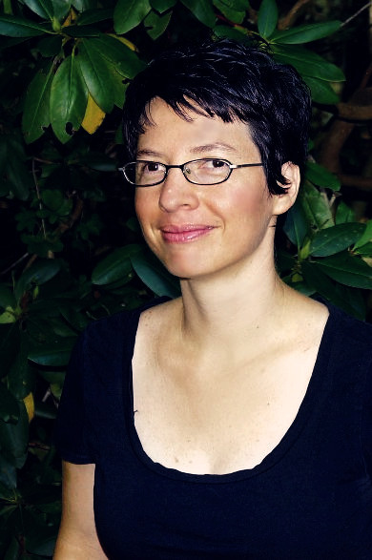
Led by Cynthia Calhoun. Cynthia, our RCS Marketing Coordinator, has worked in the field of education since 2006. She has spent well over a decade studying meditation and mindfulness along with principles of personal development. She strives to find balance in hectic modern life and continuously explores ways to do so through research and active engagement in her own regular mindfulness practice. In addition to the marketing she does for Rainbow, she maintains her own website that “spreads love and compassion through creativity”. Her workshop will feature her recently published mindfulness coloring book.
Yoga for Resiliency and Trauma Recovery- This workshop provides a blend of experiential and didactic learning about trauma, resiliency and how yoga can help you and your students become more resilient. Our time together will help you to understand trauma and to create compassionate connection! You will learn the neuroscience of yoga around resiliency & trauma; how yoga promotes resiliency & inspires change; how to create a trauma-sensitive classroom; mindfulness techniques that help create connection with the body & mind; how to utilize yoga principles & practices in a classroom setting for all populations; the therapeutic benefits of gentle movement, breathing and mindfulness practices; and easy & portable techniques to take trauma-sensitive yoga off the mat and into the classroom.

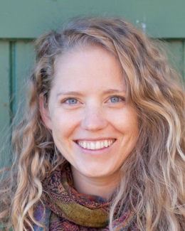
Led by Becca Odom. Becca is a Licensed Clinical Social Worker and Registered Yoga Teacher. Becca's passion is to empower others to heal themselves and to provide individuals with the skills to create lasting change in their lives. Becca works individually with young women age 10-25, where she combines transformational counseling with mindful yoga techniques to create a space for deep emotional, physical, and spiritual healing. She loves empowering young women to find their voice, take back their power, and build a healthier relationship with themselves and their bodies. Her goal is to empower individuals and families to decrease the effects of anxiety, trauma, and stress by increasing their self-awareness, self-regulation, and compassionate communication skills in their daily life. You can find out more about her private practice at www.soulfulmountaintherapy.com and about her Yoga for Resiliency and Trauma Recovery training programs at www.yogafortrauma.co.

Graphic Facilitation by Caryn Hanna
Caryn Hanna will be graphically facilitating many of our workshops. She offers a colorful and creative way of capturing the workshop content and group wisdom that emerges from the rich discussions. See images from last year’s conference by visiting our website at www.rainbowcommunityschool.org/more-than-mindfulness-conference/.

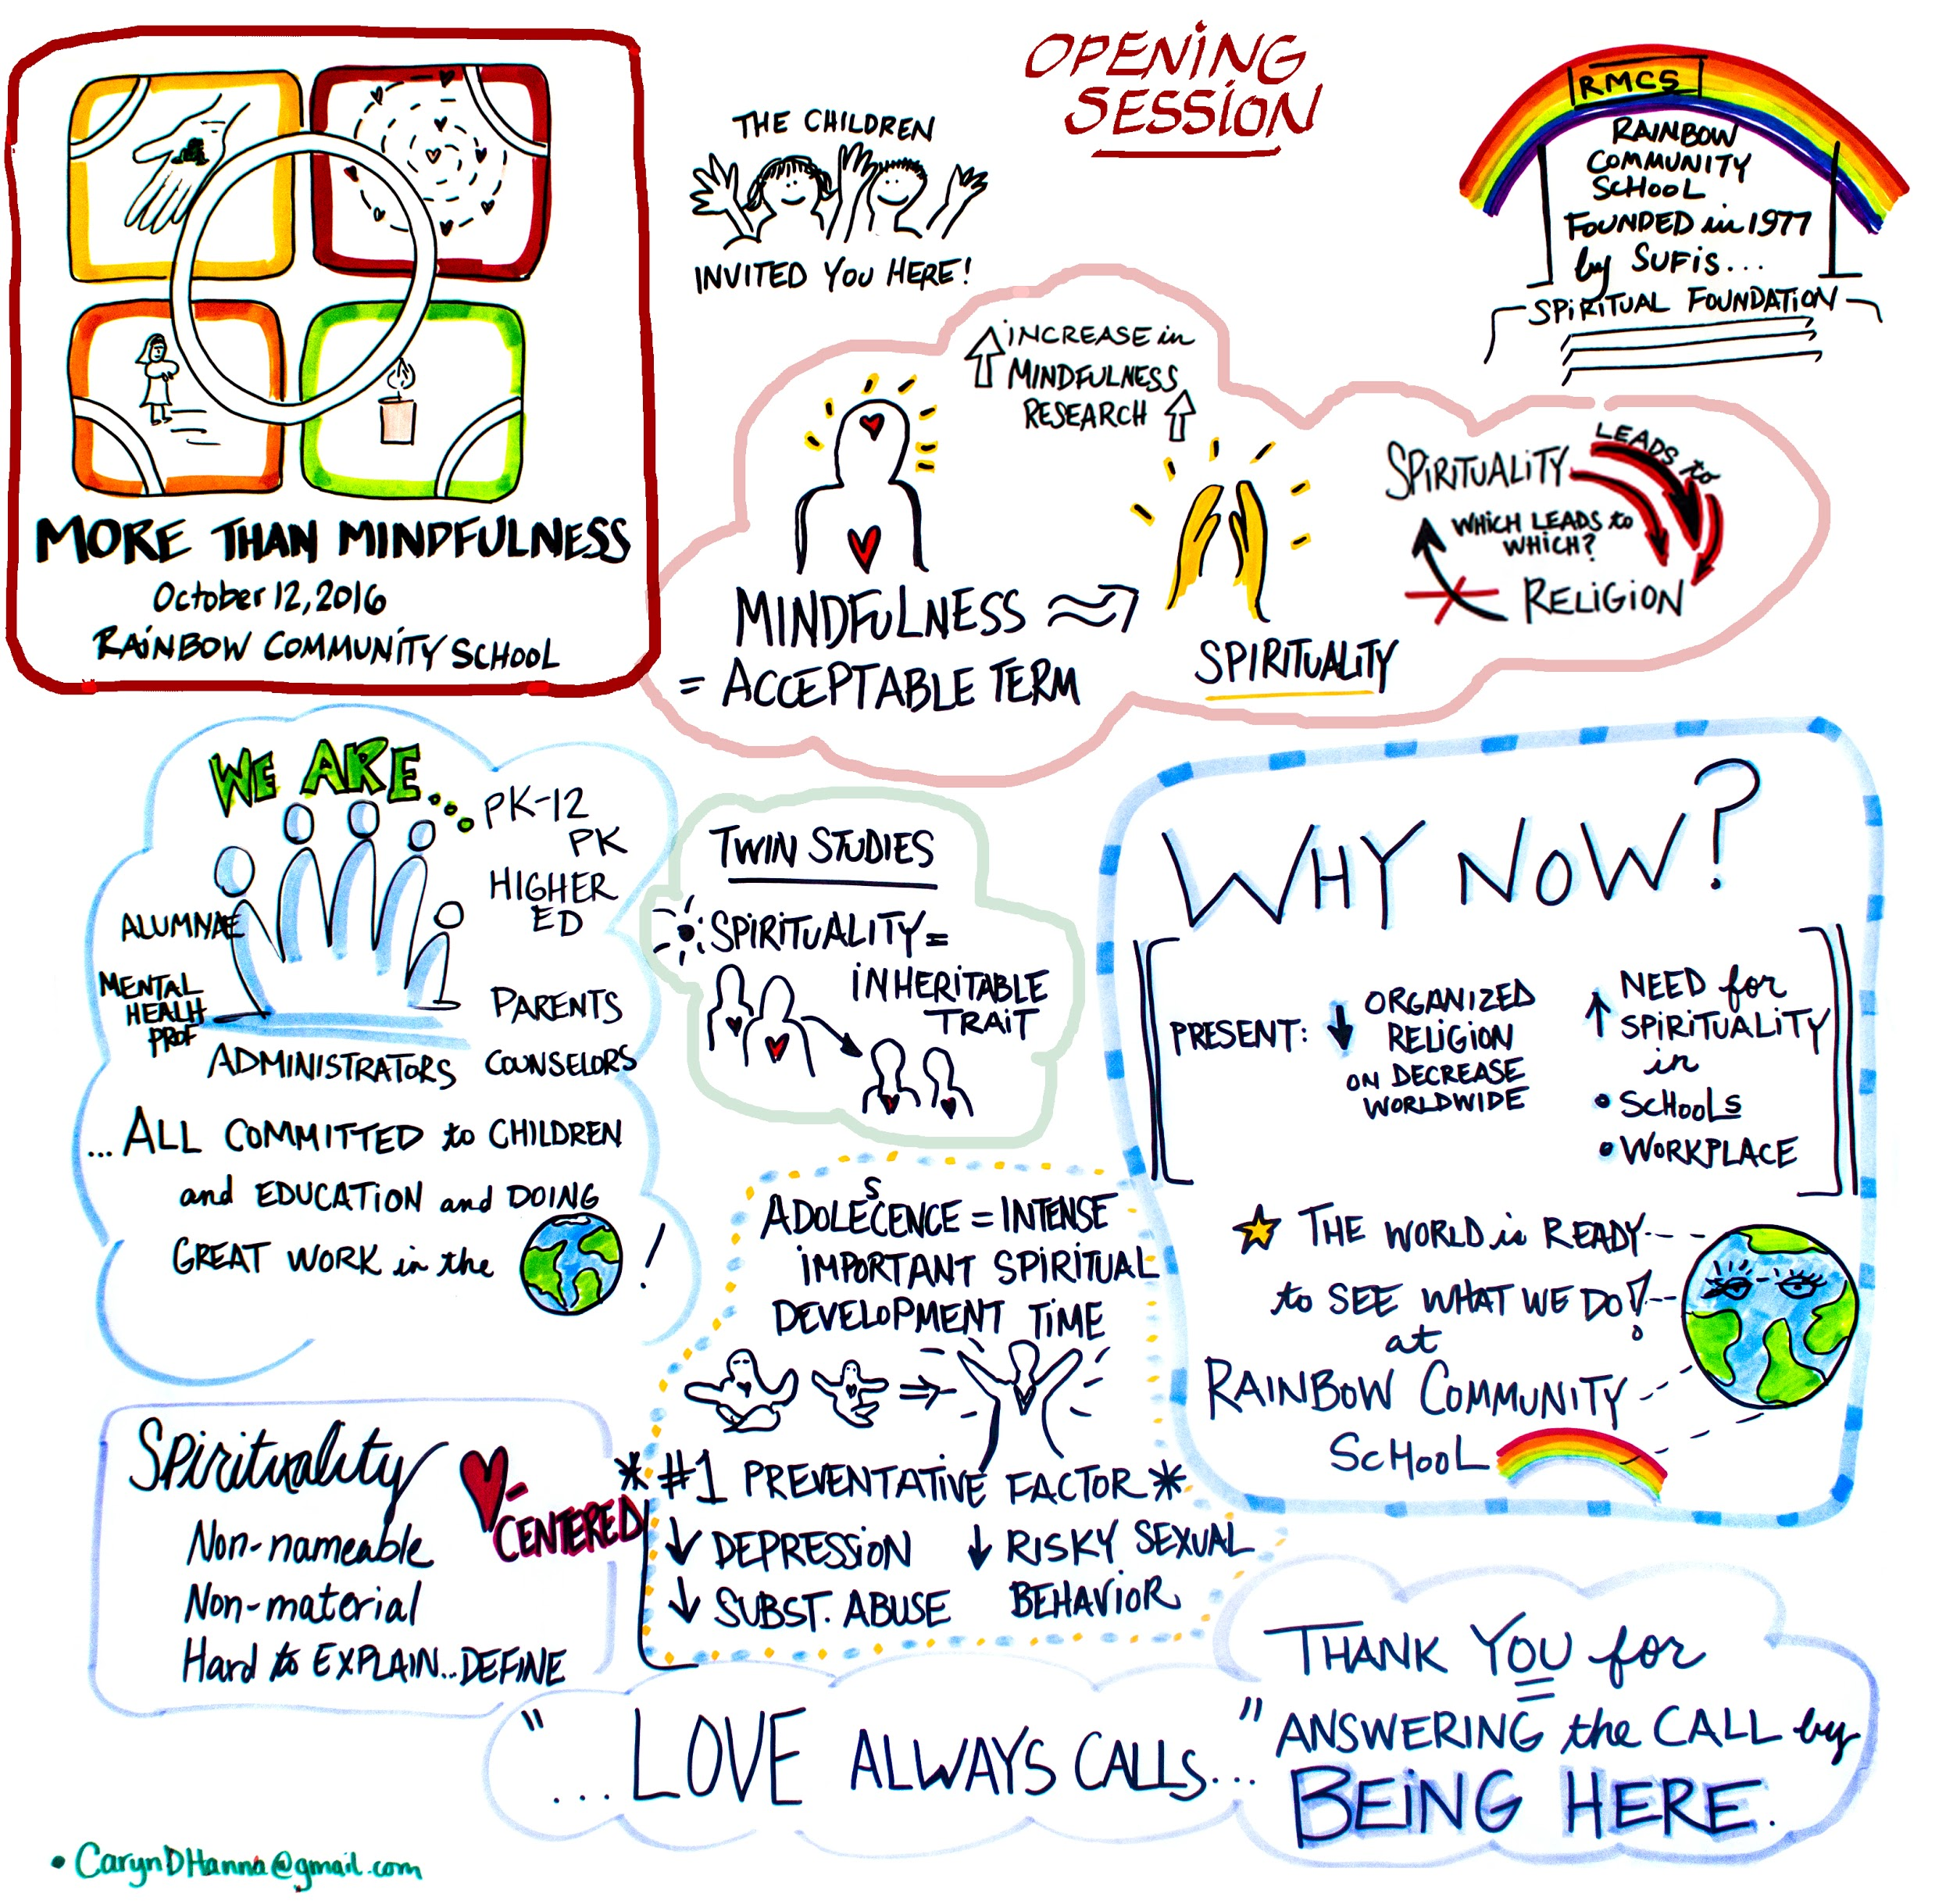
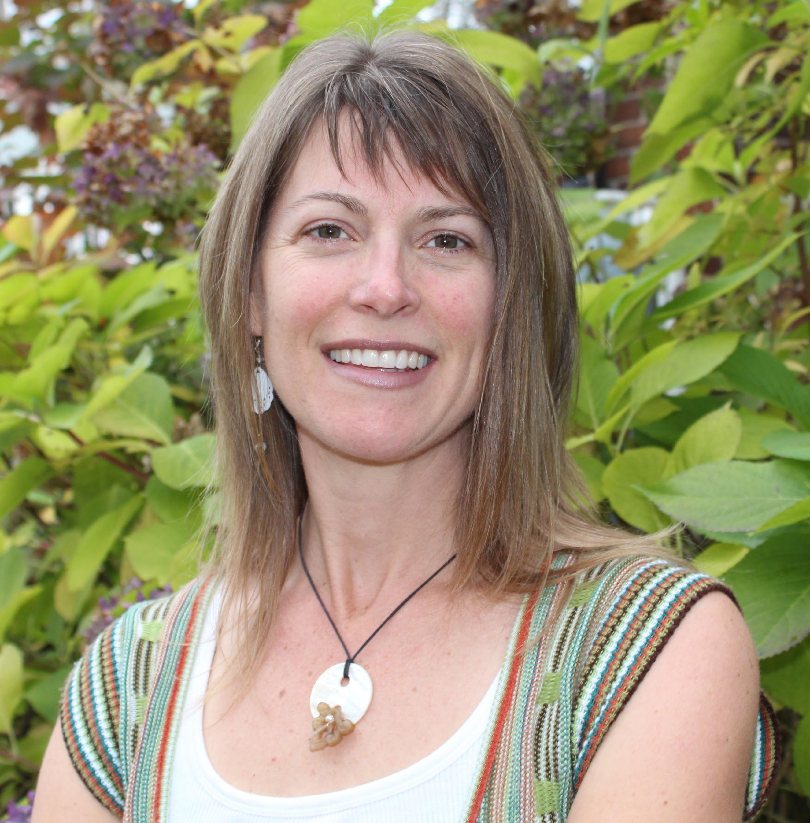
With a history of “loving meetings” for their collaborative and learning-rich content and a passion for identifying “teachable moments” in a myriad of situations, Caryn is enlivened by engaging with people and purpose through her practice of graphic facilitation. In addition to using reflective graphics to capture group conversation in real-time, Caryn prepares visuals for professionals to use to demonstrate talking points for their group presentations. She is passionate about contributing to the growth of social movements within her local community particularly in the realms of social justice, food and farming, and education. Caryn works as an independent contractor hired by an event coordinator, as partner to a group facilitator, or as a member of a facilitation team. She works with local and national corporate and nonprofit organizations. Caryn’s creative adventure extends beyond the boardroom to the wild playground of the rivers and forests in the mountains of Asheville, North Carolina.

Other Offerings:
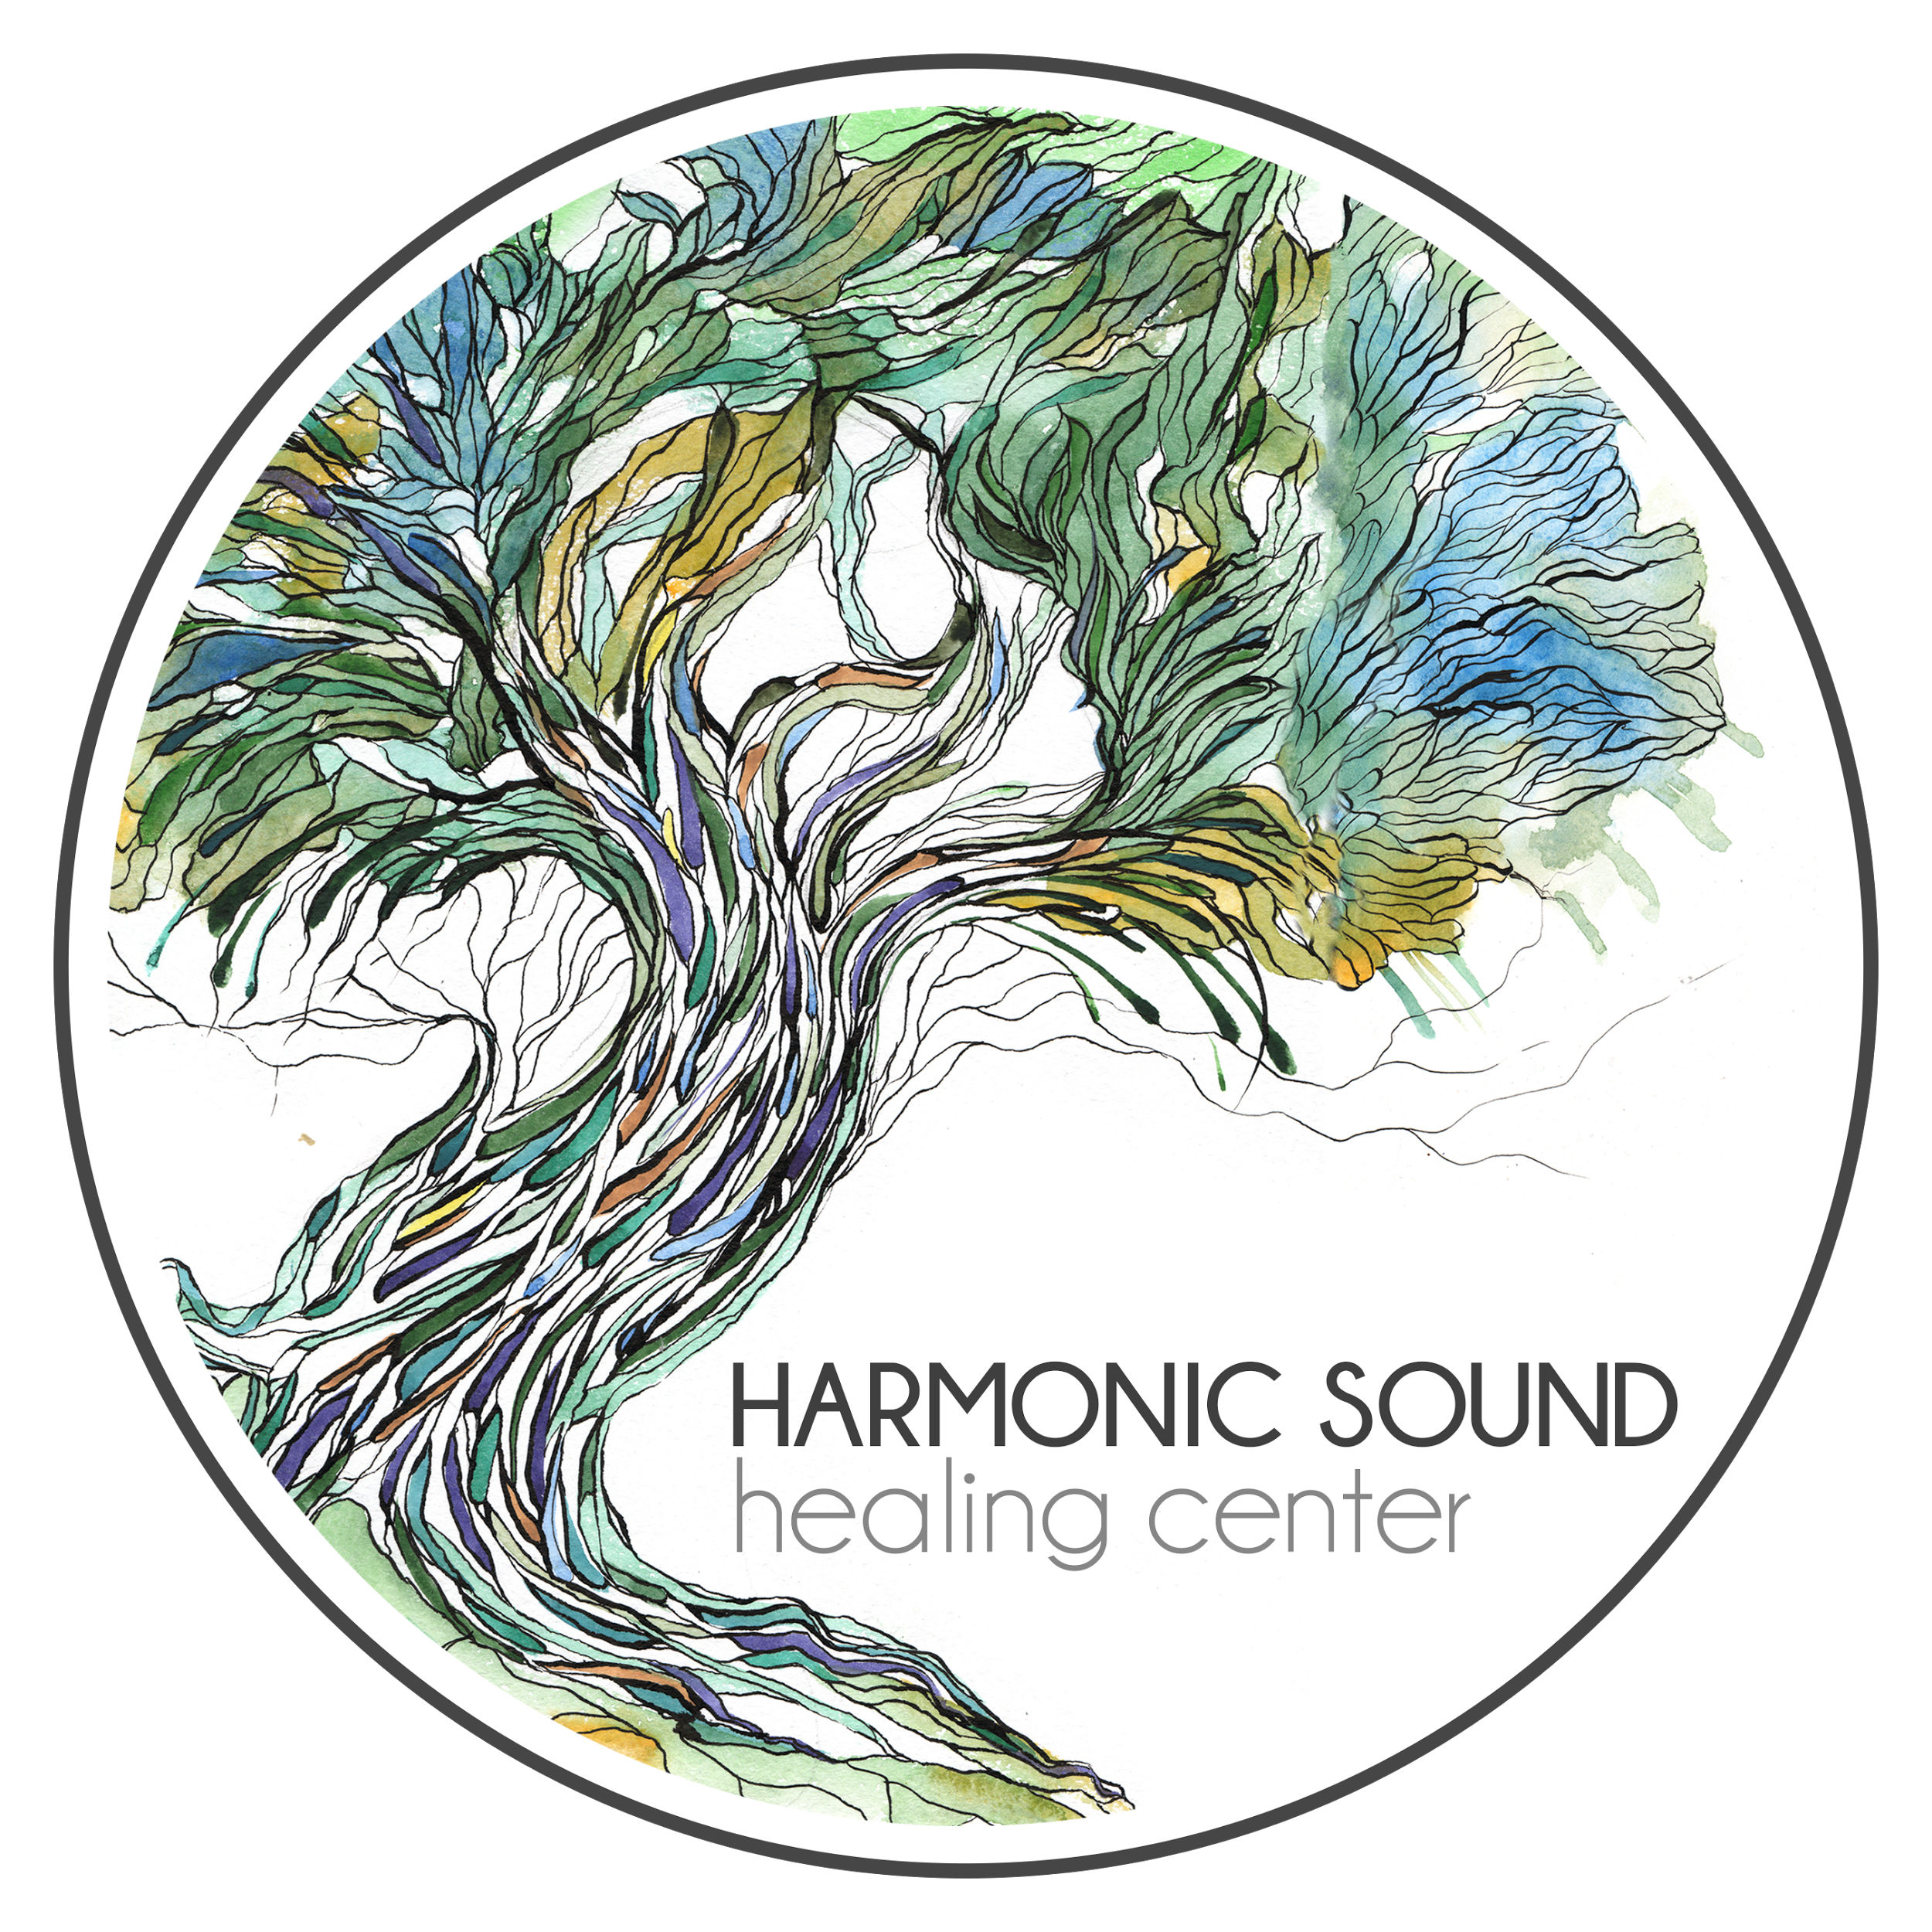
- Local restaurants will be offering discounts for MTM participants.
- Cecilia’s Food Truck will be available on Saturday from 12:00-1:15.
- Malaprop’s Bookstore will host a bookstore featuring books anchored in themes of holistic education.
- Katie McDaniel, a Rainbow teacher and certified yoga instructor, will be offering a yoga session during lunch on Saturday.
- Annie Hagen of Harmonic Sound Healing Center will be offering a sound healing session during lunch on Saturday as well.
- RCS campus tours will be available
- If looking for consulting services, you can schedule a time to meet with Rainbow Institute Co-Founder, Renee Owen.

